-

Chiyoung Jeffrey Lii

Clii01@syr.edu

Stock and Technical Analysis Database

A quick and reliable trading resource

Contents

Project Summary 2

Entity and Attribute Tables 3

Entity-Relationship Diagram 6

Business Rules 6

Creation of tables 7

Insert Statements 14

Suggestions and Improvements 33

Data Questions 34

Get all the stock price data for a particular day 34

Find the best Recommendation Strategy 35

Find the Weighted Daily Price for the first quarter of 2019, for a particular stock 36

Find the highest and lowest weighted price for the month of March 37

Find all the days the weighted stock price is above or below the Bollinger Bands for the SPY stock 38

Find all days where the weighted stock price is below the 10-Day EMA 39

Forms 40

Daily Data Add/Delete Form 40

Daily Data Details Lookup/Modification 41

Add/Delete Recommendation Strategy and Version Form 42

Add/Delete or Modify Strategy Version and Backtest Result Form 43

Add/Delete or Modify Tickers 44

Reports 45

Daily Stock Data Report 45

Backtest Result Report 46

Weighted Daily Price Report 47

Days where the weighted stock price was below the ema 48

Days where the weighted stock price is lower than the lower Bollinger Band 49

# Project Summary

The purpose of this project is to provide information management to financial traders. There are several datatypes traders much take into consideration for every position, such as the open and close prices, the ten-day Exponential Moving Average (EMA), and the results of their trades. The process of handling and organizing this data is both tedious and prone to human error and when a single wrong digit can result in the loss of thousands of dollars, data management must be done correctly.

This database will record the opening, closing, highest, and lowest prices of a trading day, as well as three technical indicators, the EMA, Moving Average Convergence Divergence (MACD), and the Bollinger Bands (BBANDS). Finally, the database will also keep track of past strategies, and their success rates. This will allow traders to iterate and improve on their strategies.

The database can be separated into two sections, connected by a ticker table that contains a ticker symbol and a ticker key. The ‘Daily Data’ section contains information that traders can use to trade, such as the lowest price over the last 100 days (good price point to buy) and whether the stock is overbought or oversold (to know when to avoid buying or selling). The ‘Strategy’ section of the database is to allow traders to track the efficiency of their strategies. Each strategy will have multiple versions (so traders can improve), and each version will have a test result associated with it (to see how well it did).

The main advantage of using this database is that traders will be able to write programs to implement strategies in a quantitative manner. For example, while it is difficult to see what the lowest price of the last 100 days are on a chart, it is very simple to write a select statement in a SQL database.

The following document contains a table of entities and attributes that will be in the database, as well as an entity relationship diagram relating the respective entities to each other. The document also contains a list of business rules not already covered by the table and diagram, as well as a list of business questions to be answered. Finally, there is a section containing forms and reports created in Microsoft access that can be used to manipulate the data and answer the data questions.

# Entity and Attribute Tables

Ticker Entity - Represents an abbreviation used to uniquely identify publicly traded shares of a particular stock on a particular stock market. Has a one to many relationship with the Backtest_Results and Daily_data entities.

|  |  |  |  |  |
| --- | --- | --- | --- | --- |
| **Constraints** | **Attribute Name** | **Field Type** | **Null/Not Null** | **Description** |
| Primary Key | Ticker_Key | Integer | Not Null | Surrogate primary key for the ticker entity |
| UNIQUE | Ticker_symbol | VarChar | Not Null | An abbreviation of the stock used by a stock exchange to represent a stock |

Daily Data Entity – A lookup table connecting individual stocks to their daily data. Represents a many to many relationships between the Ticker entity and the Time Series Daily, EMA, MACD, and BBANDS entities. Has a many to one relationship with the Ticker entity, and a one to one relationship with the Time Series Daily, EMA, MACD, and BBANDS entities.

|  |  |  |  |  |
| --- | --- | --- | --- | --- |
| **Constraints** | **Attribute Name** | **Field Type** | **Null/Not Null** | **Description** |
| Primary Key | Daily_data_key | Integer | Not Null | Surrogate primary key for the daily data entity |
| Foreign Key | Ticker_key | Integer | Not Null | Ticker the data is about |
|  | Day | Date | Not Null | Day the data is on |

Time Series Daily Entity – A table containing interesting prices of a stock on a particular day. Has a one to one relationship with the Daily Data Entity.

|  |  |  |  |  |
| --- | --- | --- | --- | --- |
| **Constraints** | **Attribute Name** | **Field Type** | **Null/Not Null** | **Description** |
| Primary Key | Time_series_daily_key | Integer | Not Null | Surrogate primary key for the time series daily entity |
| Foreign Key | Daily_Data_Key | Integer | Not Null | Which day the time series data is on |
|  | Open | Float | Not Null | Opening price of the stock on that day |
|  | Close | Float | Not Null | Closing price of the stock on that day |
|  | High | Float | Not Null | Highest price of the stock on that day |
|  | Low | Float | Not Null | Lowest price of the stock on that day |

EMA Entity - The 10 day exponential moving average of a stock price on a particular day. Has a one to one relationship with the Daily Data Entity.

|  |  |  |  |  |
| --- | --- | --- | --- | --- |
| **Constraints** | **Attribute Name** | **Field Type** | **Null/Not Null** | **Description** |
| Primary Key | Ema_key | Integer | Not Null | Surrogate primary key for the EMA entity |
|  | Ema | Float | Not Null | EMA value for the day (in numbers) |
| Foreign Key | Daily_data_key | Integer | Not Null | Which day the EMA data is on |

MACD Entity - The Moving Average Convergence Divergence of a stock price on a particular day. Has a one to one relationship with the Daily Data Entity.

|  |  |  |  |  |
| --- | --- | --- | --- | --- |
| **Constraints** | **Attribute Name** | **Field Type** | **Null/Not Null** | **Description** |
| Primary Key | Macd_Key | Integer | Not Null | Surrogate primary key for the MACD entity |
|  | Macd_Hist | Float | Nullable | Macd histogram value on that day. The difference between the macd and the signal line. |
|  | Macd_signal | Float | Nullable | Signal line used to determine macd_hist. Using the 9 day EMA. |
|  | Macd | Float | Not Null | The MACD value. Currently using the difference between the 26 period and 12 period EMA. |
| Foreign Key | Daily_data_key | Integer | Not Null | Which day the MACD is on |

BBANDS Entity - The Bollinger Band data for a stock on a particular day. Has a one to one relationship with the Daily Data Entity.

|  |  |  |  |  |
| --- | --- | --- | --- | --- |
| **Constraints** | **Attribute Name** | **Field Type** | **Null/Not Null** | **Description** |
| Primary Key | Bbands_key | Integer | Not Null | Surrogate primary key for the BBANDS entity |
|  | Real_Middle_Band | Float | Not Null | The value the BBANDS originate from. Currently an EMA |
|  | Real_Upper_Band | Float | Not Null | Two standard deviations above the middle band |
|  | Real_Lower_Band | Float | Not Null | Two standard deviations below the middle band. |
| Foreign Key | Daily_data_key | Integer | Not Null | Which day the BBANDS are on |

Backtest Results Entity – The results of a recommendation strategy’s backtest. Has a one to one relationship with the Ticker Entity, and a one to one relationship with the Recommendation Strategy Version Entity.

|  |  |  |  |  |
| --- | --- | --- | --- | --- |
| **Constraints** | **Attribute Name** | **Field Type** | **Null/Not Null** | **Description** |
| Primary Key | Backtest_Results_  Key | Integer | Not Null | Surrogate Primary Key of the backtest results entity |
| Foreign Key | Recommendation_  version_key | Integer | Not Null | Version of the strategy being tested |
| Foreign Key | Ticker_key | Integer | Not Null | Ticker of the stock being tested |
|  | Date_tested | Date | Not Null | Day the test was run |
|  | Biggest_lost | Float | Not Null | Biggest lost found during the test |
|  | Successes | Integer | Not Null | Number of successes found during test |
|  | Failures | Integer | Not Null | Number of failures found during test |
|  | Fizzles | Integer | Not Null | Instances of signals that are neither success or failures |
|  | Total | Integer | Not Null | Total signals discovered during backtest |
|  | Percent_success | Float | Not Null | Percent of success signals found during backtest |
|  | Percent_not_failed | Float | Not Null | Percent of success + fizzle signals found during backtest |

Recommendation Strategy Version Entity – Represents a version of a recommendation strategy. Has a one to one relationship with Backtest Results Entity. Has a many to one relationship with Recommendation Strategy.

|  |  |  |  |  |
| --- | --- | --- | --- | --- |
| **Constraints** | **Attribute Name** | **Field Type** | **Null/Not Null** | **Description** |
| Primary Key | Recommendation_  Strategy_version_key | Integer | Not Null | Surrogate Primary Key for the Recommendation Strategy Version entity |
| Foreign Key | Recommendation_  Strategy_key | Integer | Not Null | The type of Recommendation strategy being versioned |
|  | Version | Integer | Not Null | Version number of recommendation strategy |

Recommendation Strategy Entity – Represents a Recommendation Strategy. Has a one to many relationship with Recommendation Strategy Version.

|  |  |  |  |  |
| --- | --- | --- | --- | --- |
| **Constraints** | **Attribute Name** | **Field Type** | **Null/Not Null** | **Description** |
| Primary Key | Recommendation_  Type_key | Integer | Not Null | Surrogate Primary Key for Recommendation Type entity |
| Check :‘Bullish’ or ‘Bearish’ | Trend | VarChar | Not Null | Bearish or Bullish recommendation type |
|  | Name | VarChar | Not Null | Name of recommendation strategy |
|  | Description | VarChar | Nullable | Short description of strategy |

# Entity-Relationship Diagram

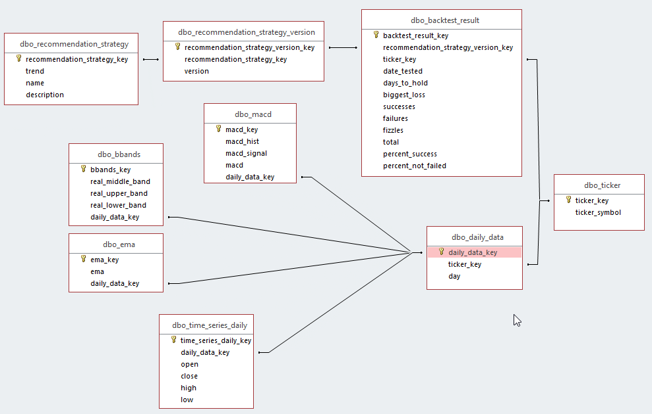

# Business Rules

1. There should be one and only one daily_data row for every combination of ticker_key and day.
2. There should only be one and only one row of time_series_daily, ema, bbands, and macd for every row of daily_data.
3. There should be one and only one row of backest_result for every row of recommendation_strategy_version.
4. “Trend” in recommendation_strategy_key can be either ‘BULLISH’ or ‘BEARISH’
5. “Version” in recommendation_strategy_version must be unique for each recommendation_strategy_key, but can be duplicated if the recommendation_strategy_keys are not the same.
6. “Ticker_Symbol” table in ticker must be unique

# Creation of tables

-- Table: ticker

CREATE TABLE ticker

(

ticker_key INTEGER NOT NULL PRIMARY KEY,

ticker_symbol VARCHAR(200) NOT NULL UNIQUE

)

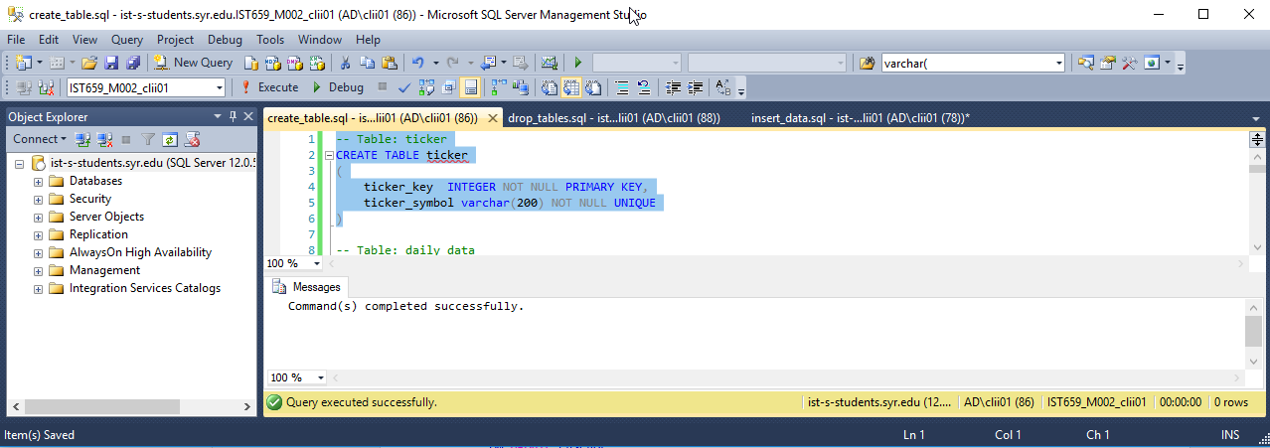

-- Table: daily_data

CREATE TABLE daily_data

(

daily_data_key INTEGER NOT NULL PRIMARY KEY,

ticker_key INTEGER NOT NULL,

"day" date NOT NULL,

CONSTRAINT ticker_key_fk FOREIGN KEY (ticker_key)

REFERENCES ticker (ticker_key)

ON UPDATE CASCADE

ON DELETE CASCADE

)

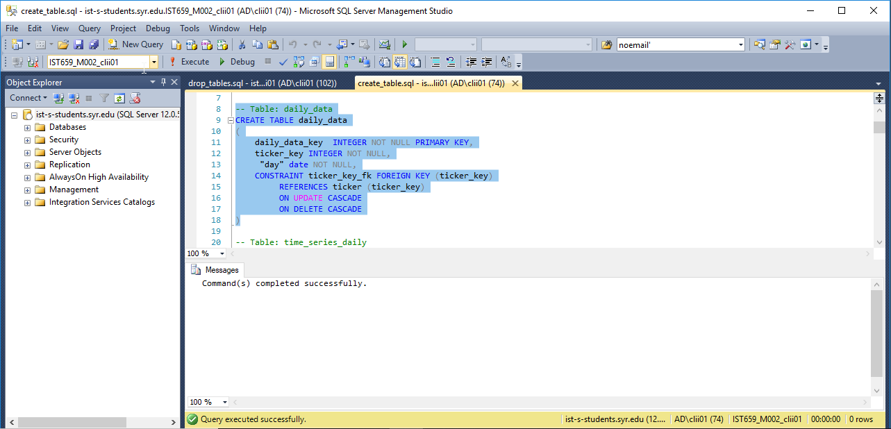

-- Table: time_series_daily

CREATE TABLE time_series_daily

(

time_series_daily_key INTEGER NOT NULL PRIMARY KEY,

daily_data_key integer NOT NULL,

"open" float NOT NULL,

"close" float NOT NULL,

high float NOT NULL,

low float NOT NULL,

CONSTRAINT tma_daily_data_fk FOREIGN KEY (daily_data_key)

REFERENCES daily_data (daily_data_key)

ON UPDATE CASCADE

ON DELETE CASCADE

)

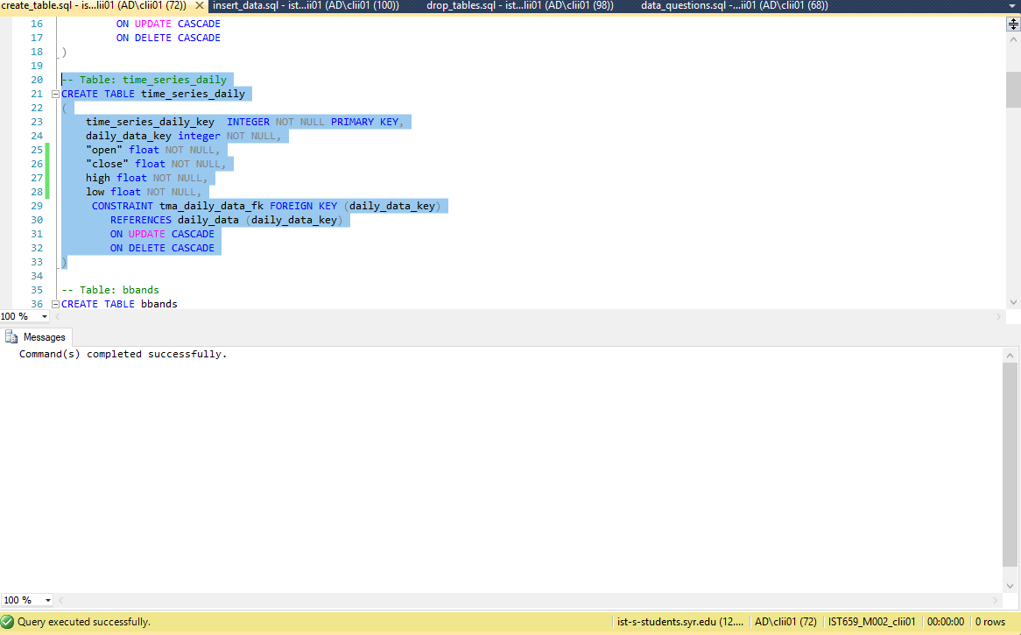

-- Table: bbands

CREATE TABLE bbands

(

bbands_key INTEGER NOT NULL PRIMARY KEY,

real_middle_band float NOT NULL,

real_upper_band float NOT NULL,

real_lower_band float NOT NULL,

daily_data_key INTEGER NOT NULL,

CONSTRAINT bbands_daily_data_fk FOREIGN KEY (daily_data_key)

REFERENCES daily_data (daily_data_key)

ON UPDATE CASCADE

ON DELETE CASCADE

)

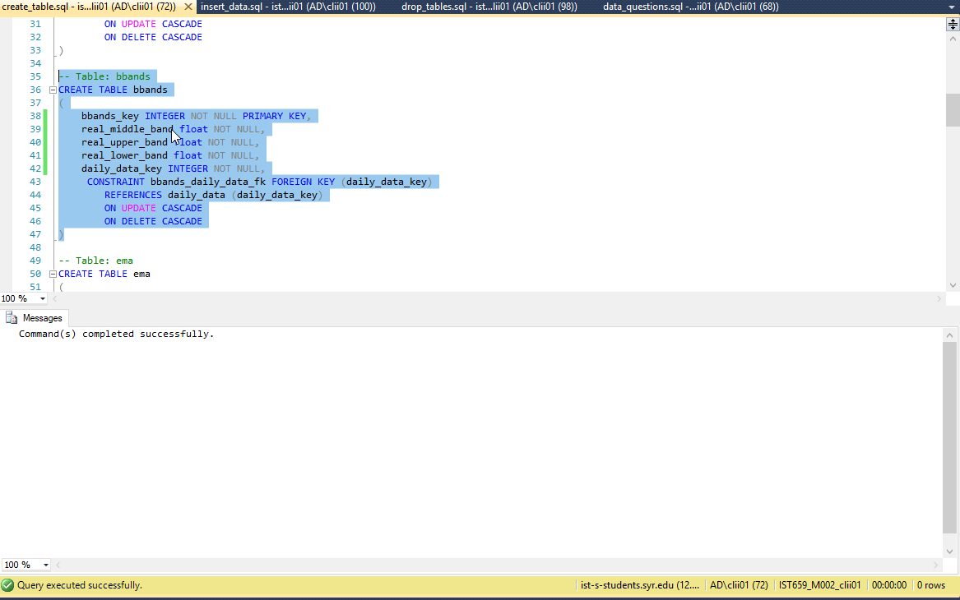

-- Table: ema

CREATE TABLE ema

(

ema_key INTEGER NOT NULL PRIMARY KEY,

ema float NOT NULL,

daily_data_key integer NOT NULL,

CONSTRAINT ema_daily_data_fk FOREIGN KEY (daily_data_key)

REFERENCES daily_data (daily_data_key)

ON UPDATE CASCADE

ON DELETE CASCADE

)

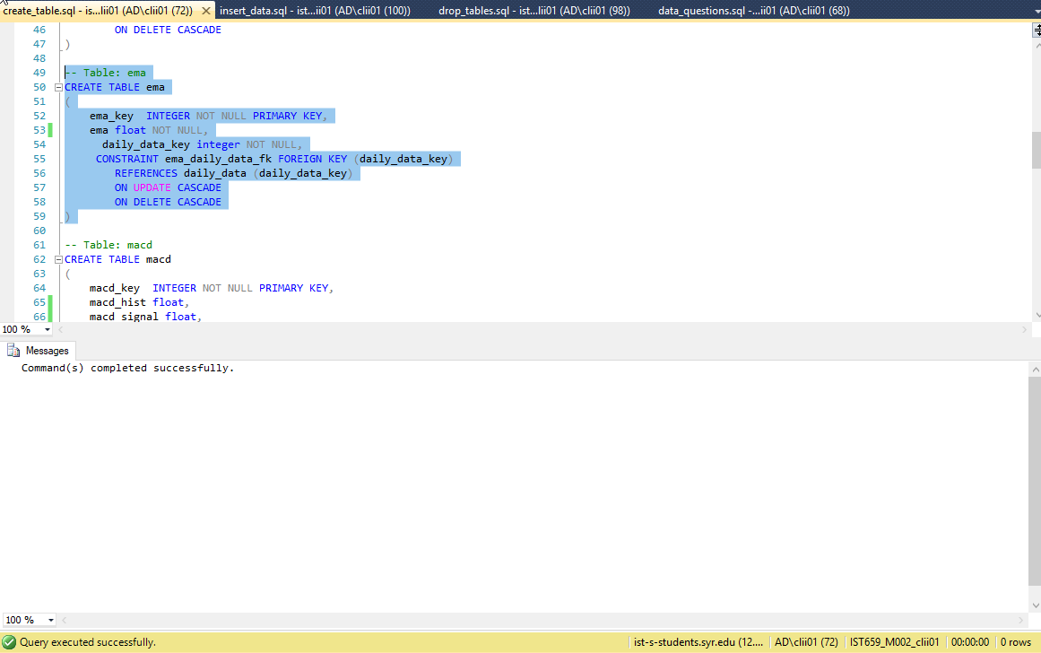

-- Table: macd

CREATE TABLE macd

(

macd_key INTEGER NOT NULL PRIMARY KEY,

macd_hist float,

macd_signal float,

macd float NOT NULL,

daily_data_key integer NOT NULL,

CONSTRAINT macd_daily_data_fk FOREIGN KEY (daily_data_key)

REFERENCES daily_data (daily_data_key)

ON UPDATE CASCADE

ON DELETE CASCADE

)

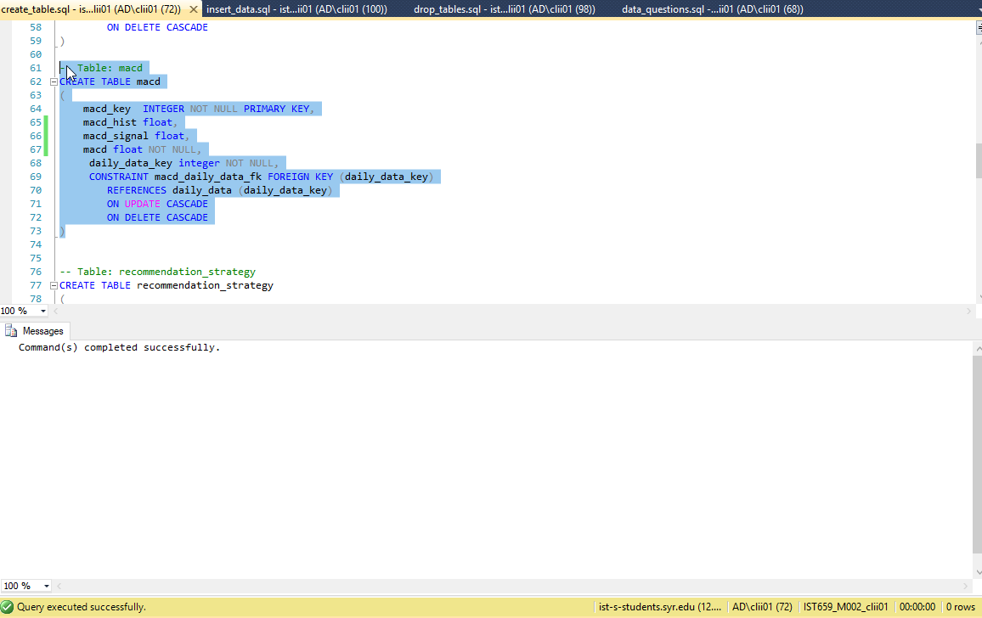

-- Table: recommendation_strategy

CREATE TABLE recommendation_strategy

(

recommendation_strategy_key INTEGER NOT NULL PRIMARY KEY,

trend varchar(200) check (trend = 'BULLISH' OR trend = 'BEARISH'),

name varchar(200) not null,

description varchar(200)

)

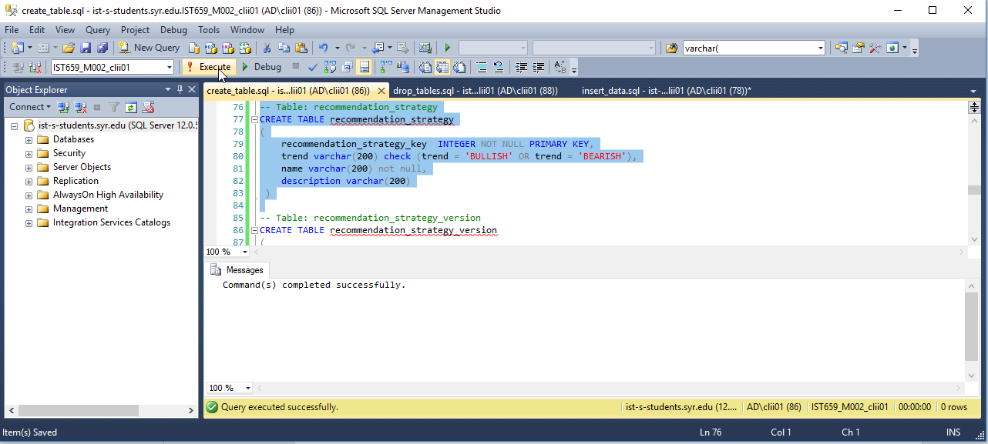

-- Table: recommendation_strategy_version

CREATE TABLE recommendation_strategy_version

(

recommendation_strategy_version_key INTEGER NOT NULL PRIMARY KEY,

recommendation_strategy_key integer NOT NULL,

version integer not null,

CONSTRAINT recommendation_strategy_fk FOREIGN KEY (recommendation_strategy_key)

REFERENCES recommendation_strategy (recommendation_strategy_key)

ON UPDATE CASCADE

ON DELETE CASCADE

)

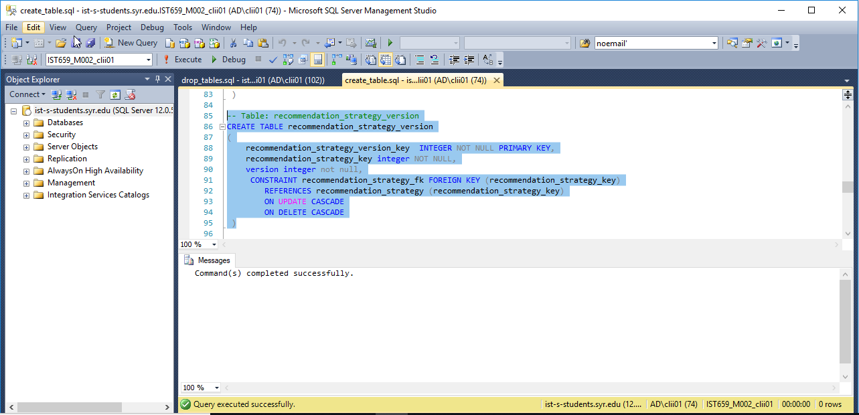

-- Table: backtest_result

create table backtest_result

(

backtest_result_key INTEGER NOT NULL PRIMARY KEY,

recommendation_strategy_version_key integer not null,

ticker_key integer not null,

date_tested date not null,

days_to_hold integer not null,

biggest_loss float not null,

successes integer not null,

failures integer not null,

fizzles integer not null,

total integer not null,

percent_success float not null,

percent_not_failed float not null,

CONSTRAINT backtest_ticker_key_fk FOREIGN KEY (ticker_key)

REFERENCES ticker (ticker_key)

ON UPDATE CASCADE

ON DELETE CASCADE,

CONSTRAINT recommendation_strategy_version_fk FOREIGN KEY (recommendation_strategy_version_key)

REFERENCES recommendation_strategy_version (recommendation_strategy_version_key)

ON UPDATE CASCADE

ON DELETE CASCADE

)

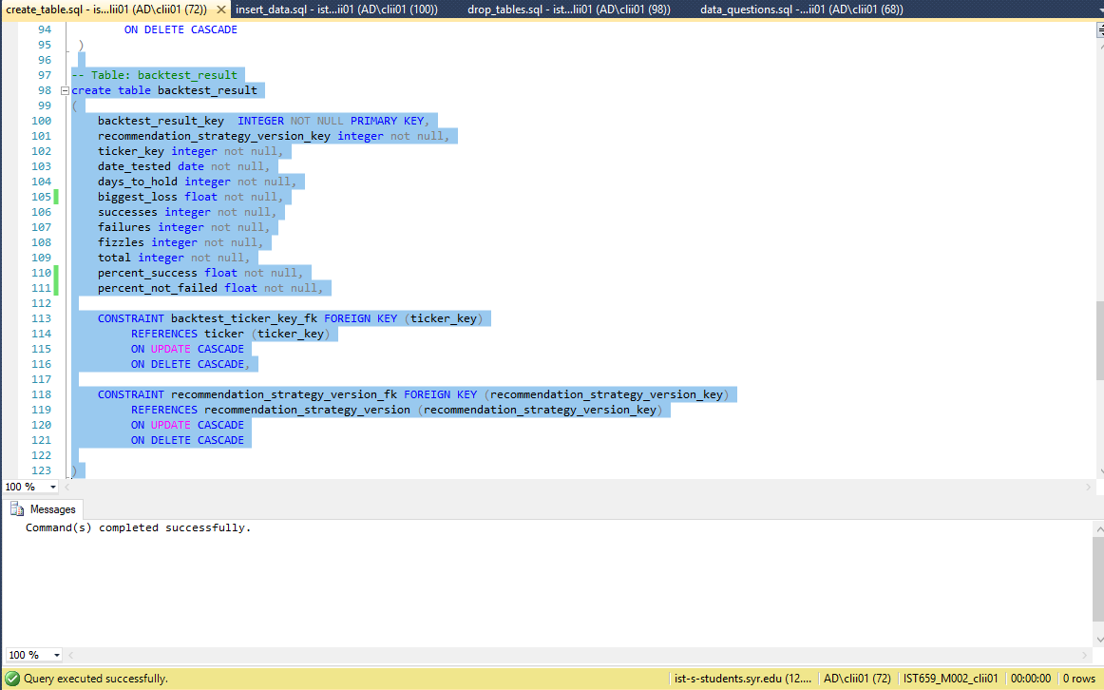

# Insert Statements

-- recommendation strategy table

INSERT INTO recommendation_strategy (recommendation_strategy_key, trend, name) VALUES (1, 'BULLISH', '10 Day EMA Crossing Bullish');

INSERT INTO recommendation_strategy (recommendation_strategy_key, trend, name, description) VALUES (2, 'BEARISH', '10 Day EMA Crossing Bearish', 'Recommends user to buy puts to sell if the stock price average for a day crosses the 10 day ema in a bearish manner');

INSERT INTO recommendation_strategy (recommendation_strategy_key, trend, name, description) VALUES (3, 'BEARISH', 'Bollinger Band Exit Bearish', 'Recommends user to buy puts to sell if the stock price average retreats from the upper Bollinger Band');

INSERT INTO recommendation_strategy (recommendation_strategy_key, trend, name, description) VALUES (4, 'BULLISH', 'Bollinger Band Exit Bullish', 'Recommends user to buy calls to sell if the stock price average retreats from the lower Bollinger Band');

-- recommendation strategy version table

INSERT INTO recommendation_strategy_version (recommendation_strategy_version_key, recommendation_strategy_key, version) VALUES (1, 1, 1);

INSERT INTO recommendation_strategy_version (recommendation_strategy_version_key, recommendation_strategy_key, version) VALUES (2, 2, 1);

INSERT INTO recommendation_strategy_version (recommendation_strategy_version_key, recommendation_strategy_key, version) VALUES (3, 3, 1);

INSERT INTO recommendation_strategy_version (recommendation_strategy_version_key, recommendation_strategy_key, version) VALUES (4, 4, 1);

-- ticker table

INSERT INTO ticker (ticker_key, ticker_symbol) VALUES (1, 'SPY');

INSERT INTO ticker (ticker_key, ticker_symbol) VALUES (2, 'AAPL');

--daily data table

INSERT INTO daily_data (daily_data_key, ticker_key, day) VALUES (1, 1, '2019-02-26');

INSERT INTO daily_data (daily_data_key, ticker_key, day) VALUES (2, 1, '2019-02-25');

INSERT INTO daily_data (daily_data_key, ticker_key, day) VALUES (3, 1, '2019-02-22');

INSERT INTO daily_data (daily_data_key, ticker_key, day) VALUES (4, 1, '2019-02-21');

INSERT INTO daily_data (daily_data_key, ticker_key, day) VALUES (5, 1, '2019-02-20');

INSERT INTO daily_data (daily_data_key, ticker_key, day) VALUES (6, 1, '2019-02-19');

INSERT INTO daily_data (daily_data_key, ticker_key, day) VALUES (7, 1, '2019-02-15');

INSERT INTO daily_data (daily_data_key, ticker_key, day) VALUES (8, 1, '2019-02-14');

INSERT INTO daily_data (daily_data_key, ticker_key, day) VALUES (9, 1, '2019-02-13');

INSERT INTO daily_data (daily_data_key, ticker_key, day) VALUES (10, 1, '2019-02-12');

INSERT INTO daily_data (daily_data_key, ticker_key, day) VALUES (11, 1, '2019-02-11');

INSERT INTO daily_data (daily_data_key, ticker_key, day) VALUES (12, 1, '2019-02-08');

INSERT INTO daily_data (daily_data_key, ticker_key, day) VALUES (13, 1, '2019-02-07');

INSERT INTO daily_data (daily_data_key, ticker_key, day) VALUES (14, 1, '2019-02-06');

INSERT INTO daily_data (daily_data_key, ticker_key, day) VALUES (15, 1, '2019-02-05');

INSERT INTO daily_data (daily_data_key, ticker_key, day) VALUES (16, 1, '2019-02-04');

INSERT INTO daily_data (daily_data_key, ticker_key, day) VALUES (17, 1, '2019-02-01');

INSERT INTO daily_data (daily_data_key, ticker_key, day) VALUES (18, 1, '2019-01-31');

INSERT INTO daily_data (daily_data_key, ticker_key, day) VALUES (19, 1, '2019-01-30');

INSERT INTO daily_data (daily_data_key, ticker_key, day) VALUES (20, 1, '2019-01-29');

INSERT INTO daily_data (daily_data_key, ticker_key, day) VALUES (21, 1, '2019-01-28');

INSERT INTO daily_data (daily_data_key, ticker_key, day) VALUES (22, 1, '2019-01-25');

INSERT INTO daily_data (daily_data_key, ticker_key, day) VALUES (23, 1, '2019-01-24');

INSERT INTO daily_data (daily_data_key, ticker_key, day) VALUES (24, 1, '2019-01-23');

INSERT INTO daily_data (daily_data_key, ticker_key, day) VALUES (25, 1, '2019-01-22');

INSERT INTO daily_data (daily_data_key, ticker_key, day) VALUES (26, 1, '2019-01-18');

INSERT INTO daily_data (daily_data_key, ticker_key, day) VALUES (27, 1, '2019-01-17');

INSERT INTO daily_data (daily_data_key, ticker_key, day) VALUES (28, 1, '2019-01-16');

INSERT INTO daily_data (daily_data_key, ticker_key, day) VALUES (29, 1, '2019-01-15');

INSERT INTO daily_data (daily_data_key, ticker_key, day) VALUES (30, 1, '2019-01-14');

INSERT INTO daily_data (daily_data_key, ticker_key, day) VALUES (31, 1, '2019-01-11');

INSERT INTO daily_data (daily_data_key, ticker_key, day) VALUES (32, 1, '2019-01-10');

INSERT INTO daily_data (daily_data_key, ticker_key, day) VALUES (33, 1, '2019-01-09');

INSERT INTO daily_data (daily_data_key, ticker_key, day) VALUES (34, 1, '2019-01-08');

INSERT INTO daily_data (daily_data_key, ticker_key, day) VALUES (35, 1, '2019-01-07');

INSERT INTO daily_data (daily_data_key, ticker_key, day) VALUES (36, 1, '2019-01-04');

INSERT INTO daily_data (daily_data_key, ticker_key, day) VALUES (37, 1, '2019-01-03');

INSERT INTO daily_data (daily_data_key, ticker_key, day) VALUES (38, 1, '2019-01-02');

INSERT INTO daily_data (daily_data_key, ticker_key, day) VALUES (101, 1, '2019-03-04');

INSERT INTO daily_data (daily_data_key, ticker_key, day) VALUES (102, 1, '2019-03-01');

INSERT INTO daily_data (daily_data_key, ticker_key, day) VALUES (103, 1, '2019-02-28');

INSERT INTO daily_data (daily_data_key, ticker_key, day) VALUES (104, 1, '2019-02-27');

INSERT INTO daily_data (daily_data_key, ticker_key, day) VALUES (105, 1, '2019-03-06');

INSERT INTO daily_data (daily_data_key, ticker_key, day) VALUES (106, 1, '2019-03-05');

INSERT INTO daily_data (daily_data_key, ticker_key, day) VALUES (107, 1, '2019-03-11');

INSERT INTO daily_data (daily_data_key, ticker_key, day) VALUES (108, 1, '2019-03-08');

INSERT INTO daily_data (daily_data_key, ticker_key, day) VALUES (109, 1, '2019-03-07');

INSERT INTO daily_data (daily_data_key, ticker_key, day) VALUES (110, 1, '2019-03-12');

INSERT INTO daily_data (daily_data_key, ticker_key, day) VALUES (111, 1, '2019-03-13');

INSERT INTO daily_data (daily_data_key, ticker_key, day) VALUES (112, 1, '2019-03-15');

INSERT INTO daily_data (daily_data_key, ticker_key, day) VALUES (113, 1, '2019-03-14');

INSERT INTO daily_data (daily_data_key, ticker_key, day) VALUES (114, 1, '2019-03-21');

INSERT INTO daily_data (daily_data_key, ticker_key, day) VALUES (115, 1, '2019-03-20');

INSERT INTO daily_data (daily_data_key, ticker_key, day) VALUES (116, 1, '2019-03-19');

INSERT INTO daily_data (daily_data_key, ticker_key, day) VALUES (117, 1, '2019-03-18');

INSERT INTO daily_data (daily_data_key, ticker_key, day) VALUES (118, 1, '2019-03-22');

INSERT INTO daily_data (daily_data_key, ticker_key, day) VALUES (119, 1, '2019-03-25');

INSERT INTO daily_data (daily_data_key, ticker_key, day) VALUES (120, 1, '2019-03-26');

INSERT INTO daily_data (daily_data_key, ticker_key, day) VALUES (121, 1, '2019-03-27');

INSERT INTO daily_data (daily_data_key, ticker_key, day) VALUES (122, 1, '2019-03-29');

INSERT INTO daily_data (daily_data_key, ticker_key, day) VALUES (123, 1, '2019-03-28');

INSERT INTO daily_data (daily_data_key, ticker_key, day) VALUES (124, 2, '2019-04-01');

INSERT INTO daily_data (daily_data_key, ticker_key, day) VALUES (125, 2, '2019-03-29');

INSERT INTO daily_data (daily_data_key, ticker_key, day) VALUES (126, 2, '2019-03-28');

INSERT INTO daily_data (daily_data_key, ticker_key, day) VALUES (127, 2, '2019-03-27');

INSERT INTO daily_data (daily_data_key, ticker_key, day) VALUES (128, 2, '2019-03-26');

INSERT INTO daily_data (daily_data_key, ticker_key, day) VALUES (129, 2, '2019-03-25');

INSERT INTO daily_data (daily_data_key, ticker_key, day) VALUES (130, 2, '2019-03-22');

INSERT INTO daily_data (daily_data_key, ticker_key, day) VALUES (131, 2, '2019-03-21');

INSERT INTO daily_data (daily_data_key, ticker_key, day) VALUES (132, 2, '2019-03-20');

INSERT INTO daily_data (daily_data_key, ticker_key, day) VALUES (133, 2, '2019-03-19');

INSERT INTO daily_data (daily_data_key, ticker_key, day) VALUES (134, 2, '2019-03-18');

INSERT INTO daily_data (daily_data_key, ticker_key, day) VALUES (135, 2, '2019-03-15');

INSERT INTO daily_data (daily_data_key, ticker_key, day) VALUES (136, 2, '2019-03-14');

INSERT INTO daily_data (daily_data_key, ticker_key, day) VALUES (137, 2, '2019-03-13');

INSERT INTO daily_data (daily_data_key, ticker_key, day) VALUES (138, 2, '2019-03-12');

INSERT INTO daily_data (daily_data_key, ticker_key, day) VALUES (139, 2, '2019-03-11');

INSERT INTO daily_data (daily_data_key, ticker_key, day) VALUES (140, 2, '2019-03-08');

INSERT INTO daily_data (daily_data_key, ticker_key, day) VALUES (141, 2, '2019-03-07');

INSERT INTO daily_data (daily_data_key, ticker_key, day) VALUES (142, 2, '2019-03-06');

INSERT INTO daily_data (daily_data_key, ticker_key, day) VALUES (143, 2, '2019-03-05');

INSERT INTO daily_data (daily_data_key, ticker_key, day) VALUES (144, 2, '2019-03-04');

INSERT INTO daily_data (daily_data_key, ticker_key, day) VALUES (145, 2, '2019-03-01');

INSERT INTO daily_data (daily_data_key, ticker_key, day) VALUES (146, 2, '2019-02-28');

INSERT INTO daily_data (daily_data_key, ticker_key, day) VALUES (147, 2, '2019-02-27');

INSERT INTO daily_data (daily_data_key, ticker_key, day) VALUES (148, 2, '2019-02-26');

INSERT INTO daily_data (daily_data_key, ticker_key, day) VALUES (149, 2, '2019-02-25');

INSERT INTO daily_data (daily_data_key, ticker_key, day) VALUES (150, 2, '2019-02-22');

INSERT INTO daily_data (daily_data_key, ticker_key, day) VALUES (151, 2, '2019-02-21');

INSERT INTO daily_data (daily_data_key, ticker_key, day) VALUES (152, 2, '2019-02-20');

INSERT INTO daily_data (daily_data_key, ticker_key, day) VALUES (153, 2, '2019-02-19');

INSERT INTO daily_data (daily_data_key, ticker_key, day) VALUES (154, 2, '2019-02-15');

INSERT INTO daily_data (daily_data_key, ticker_key, day) VALUES (155, 2, '2019-02-14');

INSERT INTO daily_data (daily_data_key, ticker_key, day) VALUES (156, 2, '2019-02-13');

INSERT INTO daily_data (daily_data_key, ticker_key, day) VALUES (157, 2, '2019-02-12');

INSERT INTO daily_data (daily_data_key, ticker_key, day) VALUES (158, 2, '2019-02-11');

INSERT INTO daily_data (daily_data_key, ticker_key, day) VALUES (159, 2, '2019-02-08');

INSERT INTO daily_data (daily_data_key, ticker_key, day) VALUES (160, 2, '2019-02-07');

INSERT INTO daily_data (daily_data_key, ticker_key, day) VALUES (161, 2, '2019-02-06');

INSERT INTO daily_data (daily_data_key, ticker_key, day) VALUES (162, 2, '2019-02-05');

INSERT INTO daily_data (daily_data_key, ticker_key, day) VALUES (163, 2, '2019-02-04');

INSERT INTO daily_data (daily_data_key, ticker_key, day) VALUES (164, 2, '2019-02-01');

INSERT INTO daily_data (daily_data_key, ticker_key, day) VALUES (165, 2, '2019-01-31');

INSERT INTO daily_data (daily_data_key, ticker_key, day) VALUES (166, 2, '2019-01-30');

INSERT INTO daily_data (daily_data_key, ticker_key, day) VALUES (167, 2, '2019-01-29');

INSERT INTO daily_data (daily_data_key, ticker_key, day) VALUES (168, 2, '2019-01-28');

INSERT INTO daily_data (daily_data_key, ticker_key, day) VALUES (169, 2, '2019-01-25');

INSERT INTO daily_data (daily_data_key, ticker_key, day) VALUES (170, 2, '2019-01-24');

INSERT INTO daily_data (daily_data_key, ticker_key, day) VALUES (171, 2, '2019-01-23');

INSERT INTO daily_data (daily_data_key, ticker_key, day) VALUES (172, 2, '2019-01-22');

INSERT INTO daily_data (daily_data_key, ticker_key, day) VALUES (173, 2, '2019-01-18');

INSERT INTO daily_data (daily_data_key, ticker_key, day) VALUES (174, 2, '2019-01-17');

INSERT INTO daily_data (daily_data_key, ticker_key, day) VALUES (175, 2, '2019-01-16');

INSERT INTO daily_data (daily_data_key, ticker_key, day) VALUES (176, 2, '2019-01-15');

INSERT INTO daily_data (daily_data_key, ticker_key, day) VALUES (177, 2, '2019-01-14');

INSERT INTO daily_data (daily_data_key, ticker_key, day) VALUES (178, 2, '2019-01-11');

INSERT INTO daily_data (daily_data_key, ticker_key, day) VALUES (179, 2, '2019-01-10');

INSERT INTO daily_data (daily_data_key, ticker_key, day) VALUES (180, 2, '2019-01-09');

INSERT INTO daily_data (daily_data_key, ticker_key, day) VALUES (181, 2, '2019-01-08');

INSERT INTO daily_data (daily_data_key, ticker_key, day) VALUES (182, 2, '2019-01-07');

INSERT INTO daily_data (daily_data_key, ticker_key, day) VALUES (183, 2, '2019-01-04');

INSERT INTO daily_data (daily_data_key, ticker_key, day) VALUES (184, 2, '2019-01-03');

INSERT INTO daily_data (daily_data_key, ticker_key, day) VALUES (185, 2, '2019-01-02');

INSERT INTO daily_data (daily_data_key, ticker_key, day) VALUES (224, 1, '2019-04-02');

INSERT INTO daily_data (daily_data_key, ticker_key, day) VALUES (225, 1, '2019-04-01');

--bbands table

INSERT INTO bbands (bbands_key, real_middle_band, real_upper_band, real_lower_band, daily_data_key) VALUES (1, 275.4621, 282.0974, 268.8269, 1);

INSERT INTO bbands (bbands_key, real_middle_band, real_upper_band, real_lower_band, daily_data_key) VALUES (2, 275.0179, 281.3880, 268.6477, 2);

INSERT INTO bbands (bbands_key, real_middle_band, real_upper_band, real_lower_band, daily_data_key) VALUES (3, 274.4779, 280.5022, 268.4535, 3);

INSERT INTO bbands (bbands_key, real_middle_band, real_upper_band, real_lower_band, daily_data_key) VALUES (4, 273.8293, 279.6582, 268.0003, 4);

INSERT INTO bbands (bbands_key, real_middle_band, real_upper_band, real_lower_band, daily_data_key) VALUES (5, 273.2943, 279.0815, 267.5071, 5);

INSERT INTO bbands (bbands_key, real_middle_band, real_upper_band, real_lower_band, daily_data_key) VALUES (6, 272.5207, 278.2610, 266.7805, 6);

INSERT INTO bbands (bbands_key, real_middle_band, real_upper_band, real_lower_band, daily_data_key) VALUES (7, 271.4893, 278.1448, 264.8337, 7);

INSERT INTO bbands (bbands_key, real_middle_band, real_upper_band, real_lower_band, daily_data_key) VALUES (8, 270.5171, 277.4240, 263.6103, 8);

INSERT INTO bbands (bbands_key, real_middle_band, real_upper_band, real_lower_band, daily_data_key) VALUES (9, 269.9029, 276.8558, 262.9499, 9);

INSERT INTO bbands (bbands_key, real_middle_band, real_upper_band, real_lower_band, daily_data_key) VALUES (10, 269.0857, 276.1433, 262.0281, 10);

INSERT INTO bbands (bbands_key, real_middle_band, real_upper_band, real_lower_band, daily_data_key) VALUES (11, 268.3221, 275.3576, 261.2867, 11);

INSERT INTO bbands (bbands_key, real_middle_band, real_upper_band, real_lower_band, daily_data_key) VALUES (12, 267.7679, 275.2032, 260.3325, 12);

INSERT INTO bbands (bbands_key, real_middle_band, real_upper_band, real_lower_band, daily_data_key) VALUES (13, 267.4814, 274.7861, 260.1767, 13);

INSERT INTO bbands (bbands_key, real_middle_band, real_upper_band, real_lower_band, daily_data_key) VALUES (14, 266.9686, 274.4604, 259.4767, 14);

INSERT INTO bbands (bbands_key, real_middle_band, real_upper_band, real_lower_band, daily_data_key) VALUES (15, 266.1286, 273.4794, 258.7777, 15);

INSERT INTO bbands (bbands_key, real_middle_band, real_upper_band, real_lower_band, daily_data_key) VALUES (16, 265.2179, 272.0276, 258.4081, 16);

INSERT INTO bbands (bbands_key, real_middle_band, real_upper_band, real_lower_band, daily_data_key) VALUES (17, 264.1779, 270.9985, 257.3572, 17);

INSERT INTO bbands (bbands_key, real_middle_band, real_upper_band, real_lower_band, daily_data_key) VALUES (18, 263.3864, 269.8555, 256.9173, 18);

INSERT INTO bbands (bbands_key, real_middle_band, real_upper_band, real_lower_band, daily_data_key) VALUES (19, 262.5971, 268.3352, 256.8591, 19);

INSERT INTO bbands (bbands_key, real_middle_band, real_upper_band, real_lower_band, daily_data_key) VALUES (20, 261.9107, 267.3938, 256.4276, 20);

INSERT INTO bbands (bbands_key, real_middle_band, real_upper_band, real_lower_band, daily_data_key) VALUES (21, 261.4364, 267.4425, 255.4304, 21);

INSERT INTO bbands (bbands_key, real_middle_band, real_upper_band, real_lower_band, daily_data_key) VALUES (22, 260.7664, 267.6192, 253.9136, 22);

INSERT INTO bbands (bbands_key, real_middle_band, real_upper_band, real_lower_band, daily_data_key) VALUES (23, 259.8100, 267.3045, 252.3155, 23);

INSERT INTO bbands (bbands_key, real_middle_band, real_upper_band, real_lower_band, daily_data_key) VALUES (24, 258.4286, 269.1089, 247.7483, 24);

INSERT INTO bbands (bbands_key, real_middle_band, real_upper_band, real_lower_band, daily_data_key) VALUES (25, 257.4836, 268.5672, 246.3999, 25);

INSERT INTO bbands (bbands_key, real_middle_band, real_upper_band, real_lower_band, daily_data_key) VALUES (26, 256.5593, 267.8516, 245.2670, 26);

INSERT INTO bbands (bbands_key, real_middle_band, real_upper_band, real_lower_band, daily_data_key) VALUES (27, 255.2229, 265.9251, 244.5207, 27);

INSERT INTO bbands (bbands_key, real_middle_band, real_upper_band, real_lower_band, daily_data_key) VALUES (28, 254.1593, 264.5288, 243.7898, 28);

INSERT INTO bbands (bbands_key, real_middle_band, real_upper_band, real_lower_band, daily_data_key) VALUES (29, 253.1021, 263.4923, 242.7120, 29);

INSERT INTO bbands (bbands_key, real_middle_band, real_upper_band, real_lower_band, daily_data_key) VALUES (30, 251.2443, 264.6501, 237.8384, 30);

INSERT INTO bbands (bbands_key, real_middle_band, real_upper_band, real_lower_band, daily_data_key) VALUES (31, 250.0514, 264.0144, 236.0885, 31);

INSERT INTO bbands (bbands_key, real_middle_band, real_upper_band, real_lower_band, daily_data_key) VALUES (32, 249.2079, 262.3118, 236.1039, 32);

INSERT INTO bbands (bbands_key, real_middle_band, real_upper_band, real_lower_band, daily_data_key) VALUES (33, 248.6636, 260.7053, 236.6219, 33);

INSERT INTO bbands (bbands_key, real_middle_band, real_upper_band, real_lower_band, daily_data_key) VALUES (34, 248.4571, 259.9397, 236.9745, 34);

INSERT INTO bbands (bbands_key, real_middle_band, real_upper_band, real_lower_band, daily_data_key) VALUES (35, 248.3564, 259.5671, 237.1457, 35);

INSERT INTO bbands (bbands_key, real_middle_band, real_upper_band, real_lower_band, daily_data_key) VALUES (36, 248.7914, 261.3007, 236.2822, 36);

INSERT INTO bbands (bbands_key, real_middle_band, real_upper_band, real_lower_band, daily_data_key) VALUES (37, 249.7186, 264.8140, 234.6232, 37);

INSERT INTO bbands (bbands_key, real_middle_band, real_upper_band, real_lower_band, daily_data_key) VALUES (38, 251.2364, 267.9930, 234.4798, 38);

INSERT INTO bbands (bbands_key, real_middle_band, real_upper_band, real_lower_band, daily_data_key) VALUES (101, 277.8700, 281.7642, 273.9758, 101);

INSERT INTO bbands (bbands_key, real_middle_band, real_upper_band, real_lower_band, daily_data_key) VALUES (102, 277.2443, 282.5325, 271.9561, 102);

INSERT INTO bbands (bbands_key, real_middle_band, real_upper_band, real_lower_band, daily_data_key) VALUES (103, 276.5336, 282.5481, 270.5190, 103);

INSERT INTO bbands (bbands_key, real_middle_band, real_upper_band, real_lower_band, daily_data_key) VALUES (104, 275.9236, 282.6355, 269.2117, 104);

INSERT INTO bbands (bbands_key, real_middle_band, real_upper_band, real_lower_band, daily_data_key) VALUES (105, 278.3900, 281.2415, 275.5385, 105);

INSERT INTO bbands (bbands_key, real_middle_band, real_upper_band, real_lower_band, daily_data_key) VALUES (106, 278.2229, 281.5397, 274.9060, 106);

INSERT INTO bbands (bbands_key, real_middle_band, real_upper_band, real_lower_band, daily_data_key) VALUES (107, 278.2146, 281.5095, 274.9197, 107);

INSERT INTO bbands (bbands_key, real_middle_band, real_upper_band, real_lower_band, daily_data_key) VALUES (108, 278.2271, 281.5151, 274.9392, 108);

INSERT INTO bbands (bbands_key, real_middle_band, real_upper_band, real_lower_band, daily_data_key) VALUES (109, 278.4350, 281.0413, 275.8287, 109);

INSERT INTO bbands (bbands_key, real_middle_band, real_upper_band, real_lower_band, daily_data_key) VALUES (110, 278.3464, 281.6889, 275.0040, 110);

INSERT INTO bbands (bbands_key, real_middle_band, real_upper_band, real_lower_band, daily_data_key) VALUES (111, 278.6264, 282.2560, 274.9969, 111);

INSERT INTO bbands (bbands_key, real_middle_band, real_upper_band, real_lower_band, daily_data_key) VALUES (112, 278.8986, 282.9563, 274.8408, 112);

INSERT INTO bbands (bbands_key, real_middle_band, real_upper_band, real_lower_band, daily_data_key) VALUES (113, 278.7707, 282.6242, 274.9173, 113);

INSERT INTO bbands (bbands_key, real_middle_band, real_upper_band, real_lower_band, daily_data_key) VALUES (114, 279.7957, 285.1358, 274.4556, 114);

INSERT INTO bbands (bbands_key, real_middle_band, real_upper_band, real_lower_band, daily_data_key) VALUES (115, 279.5471, 284.4019, 274.6924, 115);

INSERT INTO bbands (bbands_key, real_middle_band, real_upper_band, real_lower_band, daily_data_key) VALUES (116, 279.3421, 284.0823, 274.6020, 116);

INSERT INTO bbands (bbands_key, real_middle_band, real_upper_band, real_lower_band, daily_data_key) VALUES (117, 279.1136, 283.5401, 274.6871, 117);

INSERT INTO bbands (bbands_key, real_middle_band, real_upper_band, real_lower_band, daily_data_key) VALUES (118, 279.8443, 285.3843, 274.3043, 118);

INSERT INTO bbands (bbands_key, real_middle_band, real_upper_band, real_lower_band, daily_data_key) VALUES (119, 279.8457, 285.3848, 274.3066, 119);

INSERT INTO bbands (bbands_key, real_middle_band, real_upper_band, real_lower_band, daily_data_key) VALUES (120, 280.1164, 285.5057, 274.7271, 120);

INSERT INTO bbands (bbands_key, real_middle_band, real_upper_band, real_lower_band, daily_data_key) VALUES (121, 280.4479, 285.0541, 275.8417, 121);

INSERT INTO bbands (bbands_key, real_middle_band, real_upper_band, real_lower_band, daily_data_key) VALUES (122, 281.1829, 284.1594, 278.2063, 122);

INSERT INTO bbands (bbands_key, real_middle_band, real_upper_band, real_lower_band, daily_data_key) VALUES (123, 280.8943, 284.0873, 277.7013, 123);

INSERT INTO bbands (bbands_key, real_middle_band, real_upper_band, real_lower_band, daily_data_key) VALUES (124, 188.1471, 194.4314, 181.8629, 124);

INSERT INTO bbands (bbands_key, real_middle_band, real_upper_band, real_lower_band, daily_data_key) VALUES (125, 187.4279, 194.5055, 180.3502, 125);

INSERT INTO bbands (bbands_key, real_middle_band, real_upper_band, real_lower_band, daily_data_key) VALUES (126, 186.6386, 194.7972, 178.4800, 126);

INSERT INTO bbands (bbands_key, real_middle_band, real_upper_band, real_lower_band, daily_data_key) VALUES (127, 185.5093, 196.1898, 174.8288, 127);

INSERT INTO bbands (bbands_key, real_middle_band, real_upper_band, real_lower_band, daily_data_key) VALUES (128, 184.3686, 196.8072, 171.9300, 128);

INSERT INTO bbands (bbands_key, real_middle_band, real_upper_band, real_lower_band, daily_data_key) VALUES (129, 183.4921, 196.8219, 170.1623, 129);

INSERT INTO bbands (bbands_key, real_middle_band, real_upper_band, real_lower_band, daily_data_key) VALUES (130, 182.5486, 196.1267, 168.9704, 130);

INSERT INTO bbands (bbands_key, real_middle_band, real_upper_band, real_lower_band, daily_data_key) VALUES (131, 181.4629, 194.5709, 168.3548, 131);

INSERT INTO bbands (bbands_key, real_middle_band, real_upper_band, real_lower_band, daily_data_key) VALUES (132, 180.0257, 191.0959, 168.9555, 132);

INSERT INTO bbands (bbands_key, real_middle_band, real_upper_band, real_lower_band, daily_data_key) VALUES (133, 178.9536, 189.5627, 168.3445, 133);

INSERT INTO bbands (bbands_key, real_middle_band, real_upper_band, real_lower_band, daily_data_key) VALUES (134, 178.1207, 188.0274, 168.2140, 134);

INSERT INTO bbands (bbands_key, real_middle_band, real_upper_band, real_lower_band, daily_data_key) VALUES (135, 177.1429, 185.5348, 168.7509, 135);

INSERT INTO bbands (bbands_key, real_middle_band, real_upper_band, real_lower_band, daily_data_key) VALUES (136, 176.2936, 183.1447, 169.4425, 136);

INSERT INTO bbands (bbands_key, real_middle_band, real_upper_band, real_lower_band, daily_data_key) VALUES (137, 175.5250, 181.1757, 169.8743, 137);

INSERT INTO bbands (bbands_key, real_middle_band, real_upper_band, real_lower_band, daily_data_key) VALUES (138, 174.7643, 179.7021, 169.8264, 138);

INSERT INTO bbands (bbands_key, real_middle_band, real_upper_band, real_lower_band, daily_data_key) VALUES (139, 174.1300, 177.8874, 170.3726, 139);

INSERT INTO bbands (bbands_key, real_middle_band, real_upper_band, real_lower_band, daily_data_key) VALUES (140, 173.5607, 176.6015, 170.5199, 140);

INSERT INTO bbands (bbands_key, real_middle_band, real_upper_band, real_lower_band, daily_data_key) VALUES (141, 173.3829, 176.8205, 169.9452, 141);

INSERT INTO bbands (bbands_key, real_middle_band, real_upper_band, real_lower_band, daily_data_key) VALUES (142, 173.2614, 176.9277, 169.5951, 142);

INSERT INTO bbands (bbands_key, real_middle_band, real_upper_band, real_lower_band, daily_data_key) VALUES (143, 172.9514, 176.8652, 169.0377, 143);

INSERT INTO bbands (bbands_key, real_middle_band, real_upper_band, real_lower_band, daily_data_key) VALUES (144, 172.6200, 176.3873, 168.8527, 144);

INSERT INTO bbands (bbands_key, real_middle_band, real_upper_band, real_lower_band, daily_data_key) VALUES (145, 172.1614, 175.8053, 168.5175, 145);

INSERT INTO bbands (bbands_key, real_middle_band, real_upper_band, real_lower_band, daily_data_key) VALUES (146, 171.8357, 175.2234, 168.4480, 146);

INSERT INTO bbands (bbands_key, real_middle_band, real_upper_band, real_lower_band, daily_data_key) VALUES (147, 171.6779, 175.0114, 168.3443, 147);

INSERT INTO bbands (bbands_key, real_middle_band, real_upper_band, real_lower_band, daily_data_key) VALUES (148, 171.6329, 174.8060, 168.4598, 148);

INSERT INTO bbands (bbands_key, real_middle_band, real_upper_band, real_lower_band, daily_data_key) VALUES (149, 171.6221, 174.7596, 168.4847, 149);

INSERT INTO bbands (bbands_key, real_middle_band, real_upper_band, real_lower_band, daily_data_key) VALUES (150, 171.4093, 174.1947, 168.6239, 150);

INSERT INTO bbands (bbands_key, real_middle_band, real_upper_band, real_lower_band, daily_data_key) VALUES (151, 170.9486, 174.5602, 167.3370, 151);

INSERT INTO bbands (bbands_key, real_middle_band, real_upper_band, real_lower_band, daily_data_key) VALUES (152, 170.6186, 174.9095, 166.3276, 152);

INSERT INTO bbands (bbands_key, real_middle_band, real_upper_band, real_lower_band, daily_data_key) VALUES (153, 170.1343, 175.1482, 165.1203, 153);

INSERT INTO bbands (bbands_key, real_middle_band, real_upper_band, real_lower_band, daily_data_key) VALUES (154, 168.9736, 178.3442, 159.6030, 154);

INSERT INTO bbands (bbands_key, real_middle_band, real_upper_band, real_lower_band, daily_data_key) VALUES (155, 167.9650, 179.3243, 156.6057, 155);

INSERT INTO bbands (bbands_key, real_middle_band, real_upper_band, real_lower_band, daily_data_key) VALUES (156, 167.0336, 179.4037, 154.6634, 156);

INSERT INTO bbands (bbands_key, real_middle_band, real_upper_band, real_lower_band, daily_data_key) VALUES (157, 165.7850, 180.0208, 151.5492, 157);

INSERT INTO bbands (bbands_key, real_middle_band, real_upper_band, real_lower_band, daily_data_key) VALUES (158, 164.5729, 179.7240, 149.4217, 158);

INSERT INTO bbands (bbands_key, real_middle_band, real_upper_band, real_lower_band, daily_data_key) VALUES (159, 163.4207, 179.3523, 147.4892, 159);

INSERT INTO bbands (bbands_key, real_middle_band, real_upper_band, real_lower_band, daily_data_key) VALUES (160, 162.4500, 178.2150, 146.6850, 160);

INSERT INTO bbands (bbands_key, real_middle_band, real_upper_band, real_lower_band, daily_data_key) VALUES (161, 161.3729, 176.7257, 146.0200, 161);

INSERT INTO bbands (bbands_key, real_middle_band, real_upper_band, real_lower_band, daily_data_key) VALUES (162, 159.9943, 173.8733, 146.1153, 162);

INSERT INTO bbands (bbands_key, real_middle_band, real_upper_band, real_lower_band, daily_data_key) VALUES (163, 158.4864, 170.3074, 146.6655, 163);

INSERT INTO bbands (bbands_key, real_middle_band, real_upper_band, real_lower_band, daily_data_key) VALUES (164, 156.9686, 167.1936, 146.7435, 164);

INSERT INTO bbands (bbands_key, real_middle_band, real_upper_band, real_lower_band, daily_data_key) VALUES (165, 155.9521, 164.9303, 146.9740, 165);

INSERT INTO bbands (bbands_key, real_middle_band, real_upper_band, real_lower_band, daily_data_key) VALUES (166, 155.0493, 161.9226, 148.1760, 166);

INSERT INTO bbands (bbands_key, real_middle_band, real_upper_band, real_lower_band, daily_data_key) VALUES (167, 154.1964, 158.1293, 150.2635, 167);

INSERT INTO bbands (bbands_key, real_middle_band, real_upper_band, real_lower_band, daily_data_key) VALUES (168, 153.9157, 158.2145, 149.6170, 168);

INSERT INTO bbands (bbands_key, real_middle_band, real_upper_band, real_lower_band, daily_data_key) VALUES (169, 153.3179, 158.3836, 148.2521, 169);

INSERT INTO bbands (bbands_key, real_middle_band, real_upper_band, real_lower_band, daily_data_key) VALUES (170, 152.6393, 157.6882, 147.5904, 170);

INSERT INTO bbands (bbands_key, real_middle_band, real_upper_band, real_lower_band, daily_data_key) VALUES (171, 151.8886, 159.2664, 144.5107, 171);

INSERT INTO bbands (bbands_key, real_middle_band, real_upper_band, real_lower_band, daily_data_key) VALUES (172, 152.1743, 160.1317, 144.2168, 172);

INSERT INTO bbands (bbands_key, real_middle_band, real_upper_band, real_lower_band, daily_data_key) VALUES (173, 152.4914, 160.9417, 144.0412, 173);

INSERT INTO bbands (bbands_key, real_middle_band, real_upper_band, real_lower_band, daily_data_key) VALUES (174, 152.4493, 160.8183, 144.0803, 174);

INSERT INTO bbands (bbands_key, real_middle_band, real_upper_band, real_lower_band, daily_data_key) VALUES (175, 152.4700, 160.8740, 144.0660, 175);

INSERT INTO bbands (bbands_key, real_middle_band, real_upper_band, real_lower_band, daily_data_key) VALUES (176, 152.6293, 161.2950, 143.9636, 176);

INSERT INTO bbands (bbands_key, real_middle_band, real_upper_band, real_lower_band, daily_data_key) VALUES (177, 152.1836, 161.3407, 143.0264, 177);

INSERT INTO bbands (bbands_key, real_middle_band, real_upper_band, real_lower_band, daily_data_key) VALUES (178, 152.2357, 161.3507, 143.1207, 178);

INSERT INTO bbands (bbands_key, real_middle_band, real_upper_band, real_lower_band, daily_data_key) VALUES (179, 152.5600, 161.9777, 143.1423, 179);

INSERT INTO bbands (bbands_key, real_middle_band, real_upper_band, real_lower_band, daily_data_key) VALUES (180, 153.0664, 163.4131, 142.7198, 180);

INSERT INTO bbands (bbands_key, real_middle_band, real_upper_band, real_lower_band, daily_data_key) VALUES (181, 153.9779, 166.3077, 141.6480, 181);

INSERT INTO bbands (bbands_key, real_middle_band, real_upper_band, real_lower_band, daily_data_key) VALUES (182, 154.9200, 168.1054, 141.7346, 182);

INSERT INTO bbands (bbands_key, real_middle_band, real_upper_band, real_lower_band, daily_data_key) VALUES (183, 156.1736, 169.7923, 142.5549, 183);

INSERT INTO bbands (bbands_key, real_middle_band, real_upper_band, real_lower_band, daily_data_key) VALUES (184, 157.7943, 172.6082, 142.9803, 184);

INSERT INTO bbands (bbands_key, real_middle_band, real_upper_band, real_lower_band, daily_data_key) VALUES (185, 159.7164, 172.8170, 146.6159, 185);

INSERT INTO bbands (bbands_key, real_middle_band, real_upper_band, real_lower_band, daily_data_key) VALUES (224, 281.9586, 286.2068, 277.7103, 224);

INSERT INTO bbands (bbands_key, real_middle_band, real_upper_band, real_lower_band, daily_data_key) VALUES (225, 281.6357, 285.2951, 277.9764, 225);

-- ema table

INSERT INTO ema (ema_key, ema, daily_data_key) VALUES (1, 277.0123, 1);

INSERT INTO ema (ema_key, ema, daily_data_key) VALUES (2, 276.4995, 2);

INSERT INTO ema (ema_key, ema, daily_data_key) VALUES (3, 275.8282, 3);

INSERT INTO ema (ema_key, ema, daily_data_key) VALUES (4, 275.0923, 4);

INSERT INTO ema (ema_key, ema, daily_data_key) VALUES (5, 274.5750, 5);

INSERT INTO ema (ema_key, ema, daily_data_key) VALUES (6, 273.7228, 6);

INSERT INTO ema (ema_key, ema, daily_data_key) VALUES (7, 272.8057, 7);

INSERT INTO ema (ema_key, ema, daily_data_key) VALUES (8, 271.7914, 8);

INSERT INTO ema (ema_key, ema, daily_data_key) VALUES (9, 271.2161, 9);

INSERT INTO ema (ema_key, ema, daily_data_key) VALUES (10, 270.3774, 10);

INSERT INTO ema (ema_key, ema, daily_data_key) VALUES (11, 269.5502, 11);

INSERT INTO ema (ema_key, ema, daily_data_key) VALUES (12, 269.3125, 12);

INSERT INTO ema (ema_key, ema, daily_data_key) VALUES (13, 269.0553, 13);

INSERT INTO ema (ema_key, ema, daily_data_key) VALUES (14, 268.8142, 14);

INSERT INTO ema (ema_key, ema, daily_data_key) VALUES (15, 267.9418, 15);

INSERT INTO ema (ema_key, ema, daily_data_key) VALUES (16, 266.7955, 16);

INSERT INTO ema (ema_key, ema, daily_data_key) VALUES (17, 265.6479, 17);

INSERT INTO ema (ema_key, ema, daily_data_key) VALUES (18, 264.6674, 18);

INSERT INTO ema (ema_key, ema, daily_data_key) VALUES (19, 263.4980, 19);

INSERT INTO ema (ema_key, ema, daily_data_key) VALUES (20, 262.5908, 20);

INSERT INTO ema (ema_key, ema, daily_data_key) VALUES (21, 262.4088, 21);

INSERT INTO ema (ema_key, ema, daily_data_key) VALUES (22, 262.1085, 22);

INSERT INTO ema (ema_key, ema, daily_data_key) VALUES (23, 261.2926, 23);

INSERT INTO ema (ema_key, ema, daily_data_key) VALUES (24, 260.7910, 24);

INSERT INTO ema (ema_key, ema, daily_data_key) VALUES (25, 260.2090, 25);

INSERT INTO ema (ema_key, ema, daily_data_key) VALUES (26, 259.6199, 26);

INSERT INTO ema (ema_key, ema, daily_data_key) VALUES (27, 258.0999, 27);

INSERT INTO ema (ema_key, ema, daily_data_key) VALUES (28, 257.0199, 28);

INSERT INTO ema (ema_key, ema, daily_data_key) VALUES (29, 256.1398, 29);

INSERT INTO ema (ema_key, ema, daily_data_key) VALUES (30, 255.2042, 30);

INSERT INTO ema (ema_key, ema, daily_data_key) VALUES (31, 254.7163, 31);

INSERT INTO ema (ema_key, ema, daily_data_key) VALUES (32, 253.7688, 32);

INSERT INTO ema (ema_key, ema, daily_data_key) VALUES (33, 252.6330, 33);

INSERT INTO ema (ema_key, ema, daily_data_key) VALUES (34, 251.4469, 34);

INSERT INTO ema (ema_key, ema, daily_data_key) VALUES (35, 250.2640, 35);

INSERT INTO ema (ema_key, ema, daily_data_key) VALUES (36, 249.3494, 36);

INSERT INTO ema (ema_key, ema, daily_data_key) VALUES (37, 248.6737, 37);

INSERT INTO ema (ema_key, ema, daily_data_key) VALUES (38, 249.6656, 38);

INSERT INTO ema (ema_key, ema, daily_data_key) VALUES (101, 278.3706, 101);

INSERT INTO ema (ema_key, ema, daily_data_key) VALUES (102, 278.1462, 102);

INSERT INTO ema (ema_key, ema, daily_data_key) VALUES (103, 277.6410, 103);

INSERT INTO ema (ema_key, ema, daily_data_key) VALUES (104, 277.4101, 104);

INSERT INTO ema (ema_key, ema, daily_data_key) VALUES (105, 278.2804, 105);

INSERT INTO ema (ema_key, ema, daily_data_key) VALUES (106, 278.4916, 106);

INSERT INTO ema (ema_key, ema, daily_data_key) VALUES (107, 277.1976, 107);

INSERT INTO ema (ema_key, ema, daily_data_key) VALUES (108, 277.0993, 108);

INSERT INTO ema (ema_key, ema, daily_data_key) VALUES (109, 277.6858, 109);

INSERT INTO ema (ema_key, ema, daily_data_key) VALUES (110, 277.7334, 110);

INSERT INTO ema (ema_key, ema, daily_data_key) VALUES (111, 278.3891, 111);

INSERT INTO ema (ema_key, ema, daily_data_key) VALUES (112, 279.3324, 112);

INSERT INTO ema (ema_key, ema, daily_data_key) VALUES (113, 278.8929, 113);

INSERT INTO ema (ema_key, ema, daily_data_key) VALUES (114, 281.1592, 114);

INSERT INTO ema (ema_key, ema, daily_data_key) VALUES (115, 280.5568, 115);

INSERT INTO ema (ema_key, ema, daily_data_key) VALUES (116, 280.3361, 116);

INSERT INTO ema (ema_key, ema, daily_data_key) VALUES (117, 279.8774, 117);

INSERT INTO ema (ema_key, ema, daily_data_key) VALUES (118, 280.9400, 118);

INSERT INTO ema (ema_key, ema, daily_data_key) VALUES (119, 280.5945, 119);

INSERT INTO ema (ema_key, ema, daily_data_key) VALUES (120, 280.6901, 120);

INSERT INTO ema (ema_key, ema, daily_data_key) VALUES (121, 280.5010, 121);

INSERT INTO ema (ema_key, ema, daily_data_key) VALUES (122, 280.8919, 122);

INSERT INTO ema (ema_key, ema, daily_data_key) VALUES (123, 280.5390, 123);

INSERT INTO ema (ema_key, ema, daily_data_key) VALUES (124, 188.4264, 124);

INSERT INTO ema (ema_key, ema, daily_data_key) VALUES (125, 187.8634, 125);

INSERT INTO ema (ema_key, ema, daily_data_key) VALUES (126, 187.3997, 126);

INSERT INTO ema (ema_key, ema, daily_data_key) VALUES (127, 187.1063, 127);

INSERT INTO ema (ema_key, ema, daily_data_key) VALUES (128, 186.8032, 128);

INSERT INTO ema (ema_key, ema, daily_data_key) VALUES (129, 186.8062, 129);

INSERT INTO ema (ema_key, ema, daily_data_key) VALUES (130, 186.3764, 130);

INSERT INTO ema (ema_key, ema, daily_data_key) VALUES (131, 185.3379, 131);

INSERT INTO ema (ema_key, ema, daily_data_key) VALUES (132, 183.1707, 132);

INSERT INTO ema (ema_key, ema, daily_data_key) VALUES (133, 182.0620, 133);

INSERT INTO ema (ema_key, ema, daily_data_key) VALUES (134, 181.0691, 134);

INSERT INTO ema (ema_key, ema, daily_data_key) VALUES (135, 179.5244, 135);

INSERT INTO ema (ema_key, ema, daily_data_key) VALUES (136, 178.0588, 136);

INSERT INTO ema (ema_key, ema, daily_data_key) VALUES (137, 176.7985, 137);

INSERT INTO ema (ema_key, ema, daily_data_key) VALUES (138, 175.7070, 138);

INSERT INTO ema (ema_key, ema, daily_data_key) VALUES (139, 174.5508, 139);

INSERT INTO ema (ema_key, ema, daily_data_key) VALUES (140, 173.5843, 140);

INSERT INTO ema (ema_key, ema, daily_data_key) VALUES (141, 173.7342, 141);

INSERT INTO ema (ema_key, ema, daily_data_key) VALUES (142, 174.0084, 142);

INSERT INTO ema (ema_key, ema, daily_data_key) VALUES (143, 173.8948, 143);

INSERT INTO ema (ema_key, ema, daily_data_key) VALUES (144, 173.5314, 144);

INSERT INTO ema (ema_key, ema, daily_data_key) VALUES (145, 173.0161, 145);

INSERT INTO ema (ema_key, ema, daily_data_key) VALUES (146, 172.5819, 146);

INSERT INTO ema (ema_key, ema, daily_data_key) VALUES (147, 172.4557, 147);

INSERT INTO ema (ema_key, ema, daily_data_key) VALUES (148, 171.9192, 148);

INSERT INTO ema (ema_key, ema, daily_data_key) VALUES (149, 171.3834, 149);

INSERT INTO ema (ema_key, ema, daily_data_key) VALUES (150, 170.7509, 150);

INSERT INTO ema (ema_key, ema, daily_data_key) VALUES (151, 170.2577, 151);

INSERT INTO ema (ema_key, ema, daily_data_key) VALUES (152, 170.0794, 152);

INSERT INTO ema (ema_key, ema, daily_data_key) VALUES (153, 169.6460, 153);

INSERT INTO ema (ema_key, ema, daily_data_key) VALUES (154, 169.3607, 154);

INSERT INTO ema (ema_key, ema, daily_data_key) VALUES (155, 169.1252, 155);

INSERT INTO ema (ema_key, ema, daily_data_key) VALUES (156, 168.7531, 156);

INSERT INTO ema (ema_key, ema, daily_data_key) VALUES (157, 168.4360, 157);

INSERT INTO ema (ema_key, ema, daily_data_key) VALUES (158, 167.8906, 158);

INSERT INTO ema (ema_key, ema, daily_data_key) VALUES (159, 167.5486, 159);

INSERT INTO ema (ema_key, ema, daily_data_key) VALUES (160, 166.9127, 160);

INSERT INTO ema (ema_key, ema, daily_data_key) VALUES (161, 166.0177, 161);

INSERT INTO ema (ema_key, ema, daily_data_key) VALUES (162, 164.1905, 162);

INSERT INTO ema (ema_key, ema, daily_data_key) VALUES (163, 161.9707, 163);

INSERT INTO ema (ema_key, ema, daily_data_key) VALUES (164, 159.9086, 164);

INSERT INTO ema (ema_key, ema, daily_data_key) VALUES (165, 158.4394, 165);

INSERT INTO ema (ema_key, ema, daily_data_key) VALUES (166, 156.6615, 166);

INSERT INTO ema (ema_key, ema, daily_data_key) VALUES (167, 154.7529, 167);

INSERT INTO ema (ema_key, ema, daily_data_key) VALUES (168, 154.7691, 168);

INSERT INTO ema (ema_key, ema, daily_data_key) VALUES (169, 154.4289, 169);

INSERT INTO ema (ema_key, ema, daily_data_key) VALUES (170, 153.6887, 170);

INSERT INTO ema (ema_key, ema, daily_data_key) VALUES (171, 153.9084, 171);

INSERT INTO ema (ema_key, ema, daily_data_key) VALUES (172, 153.9058, 172);

INSERT INTO ema (ema_key, ema, daily_data_key) VALUES (173, 154.0404, 173);

INSERT INTO ema (ema_key, ema, daily_data_key) VALUES (174, 153.4228, 174);

INSERT INTO ema (ema_key, ema, daily_data_key) VALUES (175, 152.8812, 175);

INSERT INTO ema (ema_key, ema, daily_data_key) VALUES (176, 152.4236, 176);

INSERT INTO ema (ema_key, ema, daily_data_key) VALUES (177, 152.2800, 177);

INSERT INTO ema (ema_key, ema, daily_data_key) VALUES (178, 152.7867, 178);

INSERT INTO ema (ema_key, ema, daily_data_key) VALUES (179, 152.8970, 179);

INSERT INTO ema (ema_key, ema, daily_data_key) VALUES (180, 152.6964, 180);

INSERT INTO ema (ema_key, ema, daily_data_key) VALUES (181, 152.5600, 181);

INSERT INTO ema (ema_key, ema, daily_data_key) VALUES (182, 152.9622, 182);

INSERT INTO ema (ema_key, ema, daily_data_key) VALUES (183, 154.0805, 183);

INSERT INTO ema (ema_key, ema, daily_data_key) VALUES (184, 155.3740, 184);

INSERT INTO ema (ema_key, ema, daily_data_key) VALUES (185, 158.3037, 185);

INSERT INTO ema (ema_key, ema, daily_data_key) VALUES (224, 282.5334, 224);

INSERT INTO ema (ema_key, ema, daily_data_key) VALUES (225, 281.7897, 225);

-- macd table

INSERT INTO macd (macd_key, macd_hist, macd_signal, macd, daily_data_key) VALUES (1, 0.2297, 4.0686, 4.2983, 1);

INSERT INTO macd (macd_key, macd_hist, macd_signal, macd, daily_data_key) VALUES (2, 0.3260, 4.0112, 4.3372, 2);

INSERT INTO macd (macd_key, macd_hist, macd_signal, macd, daily_data_key) VALUES (3, 0.3738, 3.9297, 4.3035, 3);

INSERT INTO macd (macd_key, macd_hist, macd_signal, macd, daily_data_key) VALUES (4, 0.4003, 3.8362, 4.2365, 4);

INSERT INTO macd (macd_key, macd_hist, macd_signal, macd, daily_data_key) VALUES (5, 0.5284, 3.7361, 4.2646, 5);

INSERT INTO macd (macd_key, macd_hist, macd_signal, macd, daily_data_key) VALUES (6, 0.5335, 3.6040, 4.1375, 6);

INSERT INTO macd (macd_key, macd_hist, macd_signal, macd, daily_data_key) VALUES (7, 0.5016, 3.4707, 3.9722, 7);

INSERT INTO macd (macd_key, macd_hist, macd_signal, macd, daily_data_key) VALUES (8, 0.4070, 3.3453, 3.7523, 8);

INSERT INTO macd (macd_key, macd_hist, macd_signal, macd, daily_data_key) VALUES (9, 0.4780, 3.2435, 3.7215, 9);

INSERT INTO macd (macd_key, macd_hist, macd_signal, macd, daily_data_key) VALUES (10, 0.4419, 3.1240, 3.5659, 10);

INSERT INTO macd (macd_key, macd_hist, macd_signal, macd, daily_data_key) VALUES (11, 0.3926, 3.0135, 3.4061, 11);

INSERT INTO macd (macd_key, macd_hist, macd_signal, macd, daily_data_key) VALUES (12, 0.5915, 2.9154, 3.5069, 12);

INSERT INTO macd (macd_key, macd_hist, macd_signal, macd, daily_data_key) VALUES (13, 0.8323, 2.7675, 3.5998, 13);

INSERT INTO macd (macd_key, macd_hist, macd_signal, macd, daily_data_key) VALUES (14, 1.1402, 2.5594, 3.6997, 14);

INSERT INTO macd (macd_key, macd_hist, macd_signal, macd, daily_data_key) VALUES (15, 1.2342, 2.2744, 3.5086, 15);

INSERT INTO macd (macd_key, macd_hist, macd_signal, macd, daily_data_key) VALUES (16, 1.2111, 1.9659, 3.1769, 16);

INSERT INTO macd (macd_key, macd_hist, macd_signal, macd, daily_data_key) VALUES (17, 1.1605, 1.6631, 2.8235, 17);

INSERT INTO macd (macd_key, macd_hist, macd_signal, macd, daily_data_key) VALUES (18, 1.1519, 1.3730, 2.5249, 18);

INSERT INTO macd (macd_key, macd_hist, macd_signal, macd, daily_data_key) VALUES (19, 1.0352, 1.0850, 2.1202, 19);

INSERT INTO macd (macd_key, macd_hist, macd_signal, macd, daily_data_key) VALUES (20, 0.9858, 0.8262, 1.8120, 20);

INSERT INTO macd (macd_key, macd_hist, macd_signal, macd, daily_data_key) VALUES (21, 1.2373, 0.5797, 1.8170, 21);

INSERT INTO macd (macd_key, macd_hist, macd_signal, macd, daily_data_key) VALUES (22, 1.4908, 0.2704, 1.7612, 22);

INSERT INTO macd (macd_key, macd_hist, macd_signal, macd, daily_data_key) VALUES (23, 1.5611, -0.1023, 1.4588, 23);

INSERT INTO macd (macd_key, macd_hist, macd_signal, macd, daily_data_key) VALUES (24, 1.7711, -0.4926, 1.2786, 24);

INSERT INTO macd (macd_key, macd_hist, macd_signal, macd, daily_data_key) VALUES (25, 1.9796, -0.9353, 1.0443, 25);

INSERT INTO macd (macd_key, macd_hist, macd_signal, macd, daily_data_key) VALUES (26, 2.2162, -1.4302, 0.7860, 26);

INSERT INTO macd (macd_key, macd_hist, macd_signal, macd, daily_data_key) VALUES (27, 2.0626, -1.9843, 0.0783, 27);

INSERT INTO macd (macd_key, macd_hist, macd_signal, macd, daily_data_key) VALUES (28, 2.0302, -2.4999, -0.4697, 28);

INSERT INTO macd (macd_key, macd_hist, macd_signal, macd, daily_data_key) VALUES (29, 2.0468, -3.0075, -0.9607, 29);

INSERT INTO macd (macd_key, macd_hist, macd_signal, macd, daily_data_key) VALUES (30, 2.0099, -3.5192, -1.5093, 30);

INSERT INTO macd (macd_key, macd_hist, macd_signal, macd, daily_data_key) VALUES (31, 2.1345, -4.0217, -1.8872, 31);

INSERT INTO macd (macd_key, macd_hist, macd_signal, macd, daily_data_key) VALUES (32, 2.0524, -4.5553, -2.5029, 32);

INSERT INTO macd (macd_key, macd_hist, macd_signal, macd, daily_data_key) VALUES (33, 1.8262, -5.0684, -3.2422, 33);

INSERT INTO macd (macd_key, macd_hist, macd_signal, macd, daily_data_key) VALUES (34, 1.4789, -5.5249, -4.0460, 34);

INSERT INTO macd (macd_key, macd_hist, macd_signal, macd, daily_data_key) VALUES (35, 1.0037, -5.8947, -4.8910, 35);

INSERT INTO macd (macd_key, macd_hist, macd_signal, macd, daily_data_key) VALUES (36, 0.4906, -6.1456, -5.6549, 36);

INSERT INTO macd (macd_key, macd_hist, macd_signal, macd, daily_data_key) VALUES (37, -0.0769, -6.2682, -6.3452, 37);

INSERT INTO macd (macd_key, macd_hist, macd_signal, macd, daily_data_key) VALUES (38, -0.0520, -6.2490, -6.3010, 38);

INSERT INTO macd (macd_key, macd_hist, macd_signal, macd, daily_data_key) VALUES (101, -0.1676, 4.0315, 3.8639, 101);

INSERT INTO macd (macd_key, macd_hist, macd_signal, macd, daily_data_key) VALUES (102, -0.0556, 4.0734, 4.0178, 102);

INSERT INTO macd (macd_key, macd_hist, macd_signal, macd, daily_data_key) VALUES (103, -0.0374, 4.0874, 4.0499, 103);

INSERT INTO macd (macd_key, macd_hist, macd_signal, macd, daily_data_key) VALUES (104, 0.1125, 4.0967, 4.2092, 104);

INSERT INTO macd (macd_key, macd_hist, macd_signal, macd, daily_data_key) VALUES (105, -0.4932, 3.8366, 3.3434, 105);

INSERT INTO macd (macd_key, macd_hist, macd_signal, macd, daily_data_key) VALUES (106, -0.2880, 3.9599, 3.6718, 106);

INSERT INTO macd (macd_key, macd_hist, macd_signal, macd, daily_data_key) VALUES (107, -0.8894, 3.1731, 2.2837, 107);

INSERT INTO macd (macd_key, macd_hist, macd_signal, macd, daily_data_key) VALUES (108, -0.9855, 3.3955, 2.4100, 108);

INSERT INTO macd (macd_key, macd_hist, macd_signal, macd, daily_data_key) VALUES (109, -0.7789, 3.6418, 2.8629, 109);

INSERT INTO macd (macd_key, macd_hist, macd_signal, macd, daily_data_key) VALUES (110, -0.6672, 3.0186, 2.3514, 110);

INSERT INTO macd (macd_key, macd_hist, macd_signal, macd, daily_data_key) VALUES (111, -0.4332, 2.9103, 2.4770, 111);

INSERT INTO macd (macd_key, macd_hist, macd_signal, macd, daily_data_key) VALUES (112, -0.2200, 2.7798, 2.5598, 112);

INSERT INTO macd (macd_key, macd_hist, macd_signal, macd, daily_data_key) VALUES (113, -0.3019, 2.8348, 2.5329, 113);

INSERT INTO macd (macd_key, macd_hist, macd_signal, macd, daily_data_key) VALUES (114, -0.0092, 2.7033, 2.6941, 114);

INSERT INTO macd (macd_key, macd_hist, macd_signal, macd, daily_data_key) VALUES (115, -0.1119, 2.7056, 2.5936, 115);

INSERT INTO macd (macd_key, macd_hist, macd_signal, macd, daily_data_key) VALUES (116, -0.0676, 2.7336, 2.6660, 116);

INSERT INTO macd (macd_key, macd_hist, macd_signal, macd, daily_data_key) VALUES (117, -0.1174, 2.7505, 2.6330, 117);

INSERT INTO macd (macd_key, macd_hist, macd_signal, macd, daily_data_key) VALUES (118, -0.2344, 2.6581, 2.4236, 118);

INSERT INTO macd (macd_key, macd_hist, macd_signal, macd, daily_data_key) VALUES (119, -0.4345, 2.5494, 2.1149, 119);

INSERT INTO macd (macd_key, macd_hist, macd_signal, macd, daily_data_key) VALUES (120, -0.4277, 2.4425, 2.0148, 120);

INSERT INTO macd (macd_key, macd_hist, macd_signal, macd, daily_data_key) VALUES (121, -0.5171, 2.3132, 1.7962, 121);

INSERT INTO macd (macd_key, macd_hist, macd_signal, macd, daily_data_key) VALUES (122, -0.3692, 2.0961, 1.7269, 122);

INSERT INTO macd (macd_key, macd_hist, macd_signal, macd, daily_data_key) VALUES (123, -0.4994, 2.1884, 1.6890, 123);

INSERT INTO macd (macd_key, macd_hist, macd_signal, macd, daily_data_key) VALUES (124, -0.1306, 4.8387, 4.7081, 124);

INSERT INTO macd (macd_key, macd_hist, macd_signal, macd, daily_data_key) VALUES (125, -0.1115, 4.8714, 4.7599, 125);

INSERT INTO macd (macd_key, macd_hist, macd_signal, macd, daily_data_key) VALUES (126, -0.0386, 4.8992, 4.8607, 126);

INSERT INTO macd (macd_key, macd_hist, macd_signal, macd, daily_data_key) VALUES (127, 0.1349, 4.9089, 5.0438, 127);

INSERT INTO macd (macd_key, macd_hist, macd_signal, macd, daily_data_key) VALUES (128, 0.3546, 4.8752, 5.2297, 128);

INSERT INTO macd (macd_key, macd_hist, macd_signal, macd, daily_data_key) VALUES (129, 0.7754, 4.7865, 5.5619, 129);

INSERT INTO macd (macd_key, macd_hist, macd_signal, macd, daily_data_key) VALUES (130, 1.1139, 4.5927, 5.7065, 130);

INSERT INTO macd (macd_key, macd_hist, macd_signal, macd, daily_data_key) VALUES (131, 1.2587, 4.3142, 5.5729, 131);

INSERT INTO macd (macd_key, macd_hist, macd_signal, macd, daily_data_key) VALUES (132, 0.9104, 3.9995, 4.9099, 132);

INSERT INTO macd (macd_key, macd_hist, macd_signal, macd, daily_data_key) VALUES (133, 0.9260, 3.7719, 4.6979, 133);

INSERT INTO macd (macd_key, macd_hist, macd_signal, macd, daily_data_key) VALUES (134, 0.9845, 3.5404, 4.5249, 134);

INSERT INTO macd (macd_key, macd_hist, macd_signal, macd, daily_data_key) VALUES (135, 0.7923, 3.2943, 4.0866, 135);

INSERT INTO macd (macd_key, macd_hist, macd_signal, macd, daily_data_key) VALUES (136, 0.5649, 3.0962, 3.6611, 136);

INSERT INTO macd (macd_key, macd_hist, macd_signal, macd, daily_data_key) VALUES (137, 0.3532, 2.9550, 3.3082, 137);

INSERT INTO macd (macd_key, macd_hist, macd_signal, macd, daily_data_key) VALUES (138, 0.1486, 2.8667, 3.0153, 138);

INSERT INTO macd (macd_key, macd_hist, macd_signal, macd, daily_data_key) VALUES (139, -0.1505, 2.8295, 2.6790, 139);

INSERT INTO macd (macd_key, macd_hist, macd_signal, macd, daily_data_key) VALUES (140, -0.4516, 2.8672, 2.4155, 140);

INSERT INTO macd (macd_key, macd_hist, macd_signal, macd, daily_data_key) VALUES (141, -0.3261, 2.9801, 2.6540, 141);

INSERT INTO macd (macd_key, macd_hist, macd_signal, macd, daily_data_key) VALUES (142, -0.1002, 3.0616, 2.9614, 142);

INSERT INTO macd (macd_key, macd_hist, macd_signal, macd, daily_data_key) VALUES (143, 0.0184, 3.0867, 3.1051, 143);

INSERT INTO macd (macd_key, macd_hist, macd_signal, macd, daily_data_key) VALUES (144, 0.0584, 3.0820, 3.1405, 144);

INSERT INTO macd (macd_key, macd_hist, macd_signal, macd, daily_data_key) VALUES (145, 0.0399, 3.0674, 3.1074, 145);

INSERT INTO macd (macd_key, macd_hist, macd_signal, macd, daily_data_key) VALUES (146, 0.0521, 3.0574, 3.1095, 146);

INSERT INTO macd (macd_key, macd_hist, macd_signal, macd, daily_data_key) VALUES (147, 0.2080, 3.0444, 3.2524, 147);

INSERT INTO macd (macd_key, macd_hist, macd_signal, macd, daily_data_key) VALUES (148, 0.2198, 2.9924, 3.2123, 148);

INSERT INTO macd (macd_key, macd_hist, macd_signal, macd, daily_data_key) VALUES (149, 0.2318, 2.9375, 3.1693, 149);

INSERT INTO macd (macd_key, macd_hist, macd_signal, macd, daily_data_key) VALUES (150, 0.1990, 2.8795, 3.0786, 150);

INSERT INTO macd (macd_key, macd_hist, macd_signal, macd, daily_data_key) VALUES (151, 0.2165, 2.8298, 3.0463, 151);

INSERT INTO macd (macd_key, macd_hist, macd_signal, macd, daily_data_key) VALUES (152, 0.3795, 2.7756, 3.1552, 152);

INSERT INTO macd (macd_key, macd_hist, macd_signal, macd, daily_data_key) VALUES (153, 0.4688, 2.6808, 3.1496, 153);

INSERT INTO macd (macd_key, macd_hist, macd_signal, macd, daily_data_key) VALUES (154, 0.6450, 2.5636, 3.2086, 154);

INSERT INTO macd (macd_key, macd_hist, macd_signal, macd, daily_data_key) VALUES (155, 0.8868, 2.4023, 3.2891, 155);

INSERT INTO macd (macd_key, macd_hist, macd_signal, macd, daily_data_key) VALUES (156, 1.1248, 2.1806, 3.3054, 156);

INSERT INTO macd (macd_key, macd_hist, macd_signal, macd, daily_data_key) VALUES (157, 1.4419, 1.8994, 3.3413, 157);

INSERT INTO macd (macd_key, macd_hist, macd_signal, macd, daily_data_key) VALUES (158, 1.7272, 1.5389, 3.2662, 158);

INSERT INTO macd (macd_key, macd_hist, macd_signal, macd, daily_data_key) VALUES (159, 2.1643, 1.1071, 3.2714, 159);

INSERT INTO macd (macd_key, macd_hist, macd_signal, macd, daily_data_key) VALUES (160, 2.5647, 0.5660, 3.1308, 160);

INSERT INTO macd (macd_key, macd_hist, macd_signal, macd, daily_data_key) VALUES (161, 2.9269, -0.0752, 2.8518, 161);

INSERT INTO macd (macd_key, macd_hist, macd_signal, macd, daily_data_key) VALUES (162, 2.9250, -0.8069, 2.1181, 162);

INSERT INTO macd (macd_key, macd_hist, macd_signal, macd, daily_data_key) VALUES (163, 2.6952, -1.5381, 1.1571, 163);

INSERT INTO macd (macd_key, macd_hist, macd_signal, macd, daily_data_key) VALUES (164, 2.4239, -2.2119, 0.2119, 164);

INSERT INTO macd (macd_key, macd_hist, macd_signal, macd, daily_data_key) VALUES (165, 2.3020, -2.8179, -0.5159, 165);

INSERT INTO macd (macd_key, macd_hist, macd_signal, macd, daily_data_key) VALUES (166, 1.9641, -3.3934, -1.4293, 166);

INSERT INTO macd (macd_key, macd_hist, macd_signal, macd, daily_data_key) VALUES (167, 1.4313, -3.8844, -2.4531, 167);

INSERT INTO macd (macd_key, macd_hist, macd_signal, macd, daily_data_key) VALUES (168, 1.5943, -4.2423, -2.6480, 168);

INSERT INTO macd (macd_key, macd_hist, macd_signal, macd, daily_data_key) VALUES (169, 1.6177, -4.6408, -3.0231, 169);

INSERT INTO macd (macd_key, macd_hist, macd_signal, macd, daily_data_key) VALUES (170, 1.4386, -5.0452, -3.6067, 170);

INSERT INTO macd (macd_key, macd_hist, macd_signal, macd, daily_data_key) VALUES (171, 1.6211, -5.4049, -3.7838, 171);

INSERT INTO macd (macd_key, macd_hist, macd_signal, macd, daily_data_key) VALUES (172, 1.7312, -5.8102, -4.0790, 172);

INSERT INTO macd (macd_key, macd_hist, macd_signal, macd, daily_data_key) VALUES (173, 1.9096, -6.2430, -4.3334, 173);

INSERT INTO macd (macd_key, macd_hist, macd_signal, macd, daily_data_key) VALUES (174, 1.7669, -6.7204, -4.9535, 174);

INSERT INTO macd (macd_key, macd_hist, macd_signal, macd, daily_data_key) VALUES (175, 1.5870, -7.1621, -5.5751, 175);

INSERT INTO macd (macd_key, macd_hist, macd_signal, macd, daily_data_key) VALUES (176, 1.3651, -7.5588, -6.1937, 176);

INSERT INTO macd (macd_key, macd_hist, macd_signal, macd, daily_data_key) VALUES (177, 1.1972, -7.9001, -6.7029, 177);

INSERT INTO macd (macd_key, macd_hist, macd_signal, macd, daily_data_key) VALUES (178, 1.2568, -8.1994, -6.9426, 178);

INSERT INTO macd (macd_key, macd_hist, macd_signal, macd, daily_data_key) VALUES (179, 1.1328, -8.5136, -7.3808, 179);

INSERT INTO macd (macd_key, macd_hist, macd_signal, macd, daily_data_key) VALUES (180, 0.8103, -8.7968, -7.9865, 180);

INSERT INTO macd (macd_key, macd_hist, macd_signal, macd, daily_data_key) VALUES (181, 0.4059, -8.9994, -8.5935, 181);

INSERT INTO macd (macd_key, macd_hist, macd_signal, macd, daily_data_key) VALUES (182, 0.1182, -9.1009, -8.9827, 182);

INSERT INTO macd (macd_key, macd_hist, macd_signal, macd, daily_data_key) VALUES (183, 0.0688, -9.1304, -9.0616, 183);

INSERT INTO macd (macd_key, macd_hist, macd_signal, macd, daily_data_key) VALUES (184, 0.0836, -9.1476, -9.0640, 184);

INSERT INTO macd (macd_key, macd_hist, macd_signal, macd, daily_data_key) VALUES (185, 0.8512, -9.1685, -8.3173, 185);

INSERT INTO macd (macd_key, macd_hist, macd_signal, macd, daily_data_key) VALUES (224, 0.0999, 2.1027, 2.2026, 224);

INSERT INTO macd (macd_key, macd_hist, macd_signal, macd, daily_data_key) VALUES (225, -0.0735, 2.0777, 2.0042, 225);

-- Time series daily table

INSERT INTO time_series_daily (time_series_daily_key, daily_data_key, "open", "close", high, low) VALUES (1, 1, 279.1300, 279.3200, 280.3000, 278.9000);

INSERT INTO time_series_daily (time_series_daily_key, daily_data_key, "open", "close", high, low) VALUES (2, 2, 280.7300, 279.5200, 281.3100, 279.4300);

INSERT INTO time_series_daily (time_series_daily_key, daily_data_key, "open", "close", high, low) VALUES (3, 3, 278.1100, 279.1400, 279.3600, 277.4029);

INSERT INTO time_series_daily (time_series_daily_key, daily_data_key, "open", "close", high, low) VALUES (4, 4, 277.7000, 277.4200, 278.1000, 276.3450);

INSERT INTO time_series_daily (time_series_daily_key, daily_data_key, "open", "close", high, low) VALUES (5, 5, 277.8100, 278.4100, 278.9200, 277.2500);

INSERT INTO time_series_daily (time_series_daily_key, daily_data_key, "open", "close", high, low) VALUES (6, 6, 276.4813, 277.8500, 278.5800, 276.4700);

INSERT INTO time_series_daily (time_series_daily_key, daily_data_key, "open", "close", high, low) VALUES (7, 7, 276.3600, 277.3700, 277.4100, 276.1300);

INSERT INTO time_series_daily (time_series_daily_key, daily_data_key, "open", "close", high, low) VALUES (8, 8, 273.7800, 274.3800, 275.6400, 272.8700);

INSERT INTO time_series_daily (time_series_daily_key, daily_data_key, "open", "close", high, low) VALUES (9, 9, 275.0300, 274.9900, 275.9300, 274.5600);

INSERT INTO time_series_daily (time_series_daily_key, daily_data_key, "open", "close", high, low) VALUES (10, 10, 272.4200, 274.1000, 274.5200, 272.3400);

INSERT INTO time_series_daily (time_series_daily_key, daily_data_key, "open", "close", high, low) VALUES (11, 11, 271.2000, 270.6200, 271.4900, 270.0300);

INSERT INTO time_series_daily (time_series_daily_key, daily_data_key, "open", "close", high, low) VALUES (12, 12, 268.7500, 270.4700, 270.5800, 267.8300);

INSERT INTO time_series_daily (time_series_daily_key, daily_data_key, "open", "close", high, low) VALUES (13, 13, 270.9400, 270.1400, 271.5500, 268.2900);

INSERT INTO time_series_daily (time_series_daily_key, daily_data_key, "open", "close", high, low) VALUES (14, 14, 272.7900, 272.7400, 273.3400, 271.9200);

INSERT INTO time_series_daily (time_series_daily_key, daily_data_key, "open", "close", high, low) VALUES (15, 15, 272.4400, 273.1000, 273.4400, 271.8800);

INSERT INTO time_series_daily (time_series_daily_key, daily_data_key, "open", "close", high, low) VALUES (16, 16, 270.1100, 271.9600, 272.0300, 269.3600);

INSERT INTO time_series_daily (time_series_daily_key, daily_data_key, "open", "close", high, low) VALUES (17, 17, 270.1500, 270.0600, 271.2000, 269.1800);

INSERT INTO time_series_daily (time_series_daily_key, daily_data_key, "open", "close", high, low) VALUES (18, 18, 267.5100, 269.9300, 270.4700, 267.2700);

INSERT INTO time_series_daily (time_series_daily_key, daily_data_key, "open", "close", high, low) VALUES (19, 19, 265.1000, 267.5800, 268.5200, 264.2500);

INSERT INTO time_series_daily (time_series_daily_key, daily_data_key, "open", "close", high, low) VALUES (20, 20, 263.9200, 263.4100, 264.5500, 262.4800);

INSERT INTO time_series_daily (time_series_daily_key, daily_data_key, "open", "close", high, low) VALUES (21, 21, 263.3900, 263.7600, 263.8300, 261.7900);

INSERT INTO time_series_daily (time_series_daily_key, daily_data_key, "open", "close", high, low) VALUES (22, 22, 265.6100, 265.7800, 266.7000, 263.6595);

INSERT INTO time_series_daily (time_series_daily_key, daily_data_key, "open", "close", high, low) VALUES (23, 23, 263.2100, 263.5500, 264.2000, 262.0800);

INSERT INTO time_series_daily (time_series_daily_key, daily_data_key, "open", "close", high, low) VALUES (24, 24, 264.0100, 263.4100, 264.7900, 260.6600);

INSERT INTO time_series_daily (time_series_daily_key, daily_data_key, "open", "close", high, low) VALUES (25, 25, 264.8200, 262.8600, 265.0600, 261.0600);

INSERT INTO time_series_daily (time_series_daily_key, daily_data_key, "open", "close", high, low) VALUES (26, 26, 264.9800, 266.4600, 266.9800, 262.9980);

INSERT INTO time_series_daily (time_series_daily_key, daily_data_key, "open", "close", high, low) VALUES (27, 27, 260.0100, 262.9600, 263.9200, 259.9600);

INSERT INTO time_series_daily (time_series_daily_key, daily_data_key, "open", "close", high, low) VALUES (28, 28, 260.8300, 260.9800, 261.9666, 260.6000);

INSERT INTO time_series_daily (time_series_daily_key, daily_data_key, "open", "close", high, low) VALUES (29, 29, 257.8200, 260.3500, 260.7000, 257.8100);

INSERT INTO time_series_daily (time_series_daily_key, daily_data_key, "open", "close", high, low) VALUES (30, 30, 256.8600, 257.4000, 258.3000, 256.4100);

INSERT INTO time_series_daily (time_series_daily_key, daily_data_key, "open", "close", high, low) VALUES (31, 31, 257.6800, 258.9800, 259.0098, 257.0300);

INSERT INTO time_series_daily (time_series_daily_key, daily_data_key, "open", "close", high, low) VALUES (32, 32, 256.2600, 258.8800, 259.1600, 255.5000);

INSERT INTO time_series_daily (time_series_daily_key, daily_data_key, "open", "close", high, low) VALUES (33, 33, 257.5600, 257.9700, 258.9100, 256.1900);

INSERT INTO time_series_daily (time_series_daily_key, daily_data_key, "open", "close", high, low) VALUES (34, 34, 256.8200, 256.7700, 257.3100, 254.0000);

INSERT INTO time_series_daily (time_series_daily_key, daily_data_key, "open", "close", high, low) VALUES (35, 35, 252.6900, 254.3800, 255.9500, 251.6900);

INSERT INTO time_series_daily (time_series_daily_key, daily_data_key, "open", "close", high, low) VALUES (36, 36, 247.5900, 252.3900, 253.1100, 247.1700);

INSERT INTO time_series_daily (time_series_daily_key, daily_data_key, "open", "close", high, low) VALUES (37, 37, 248.2300, 244.2100, 248.5700, 243.6700);

INSERT INTO time_series_daily (time_series_daily_key, daily_data_key, "open", "close", high, low) VALUES (38, 38, 245.9800, 250.1800, 251.2100, 245.9500);

INSERT INTO time_series_daily (time_series_daily_key, daily_data_key, "open", "close", high, low) VALUES (101, 101, 281.6000, 279.3800, 281.8700, 276.8400);

INSERT INTO time_series_daily (time_series_daily_key, daily_data_key, "open", "close", high, low) VALUES (102, 102, 280.4400, 280.4200, 280.8800, 278.8200);

INSERT INTO time_series_daily (time_series_daily_key, daily_data_key, "open", "close", high, low) VALUES (103, 103, 278.9600, 278.6800, 279.4500, 278.3200);

INSERT INTO time_series_daily (time_series_daily_key, daily_data_key, "open", "close", high, low) VALUES (104, 104, 278.5200, 279.2000, 279.5900, 277.4800);

INSERT INTO time_series_daily (time_series_daily_key, daily_data_key, "open", "close", high, low) VALUES (105, 105, 279.1500, 277.3300, 279.1600, 276.9700);

INSERT INTO time_series_daily (time_series_daily_key, daily_data_key, "open", "close", high, low) VALUES (106, 106, 279.5400, 279.0200, 279.7600, 278.4100);

INSERT INTO time_series_daily (time_series_daily_key, daily_data_key, "open", "close", high, low) VALUES (107, 107, 275.2600, 277.6400, 277.9800, 275.2300);

INSERT INTO time_series_daily (time_series_daily_key, daily_data_key, "open", "close", high, low) VALUES (108, 108, 272.9400, 274.4600, 274.6500, 272.4200);

INSERT INTO time_series_daily (time_series_daily_key, daily_data_key, "open", "close", high, low) VALUES (109, 109, 276.8300, 275.0100, 276.9900, 274.0700);

INSERT INTO time_series_daily (time_series_daily_key, daily_data_key, "open", "close", high, low) VALUES (110, 110, 279.0600, 279.4900, 280.0700, 278.8500);

INSERT INTO time_series_daily (time_series_daily_key, daily_data_key, "open", "close", high, low) VALUES (111, 111, 280.4800, 281.3400, 282.3800, 280.3000);

INSERT INTO time_series_daily (time_series_daily_key, daily_data_key, "open", "close", high, low) VALUES (112, 112, 280.5400, 281.3100, 282.2100, 280.3300);

INSERT INTO time_series_daily (time_series_daily_key, daily_data_key, "open", "close", high, low) VALUES (113, 113, 281.3700, 281.1600, 281.8400, 280.6662);

INSERT INTO time_series_daily (time_series_daily_key, daily_data_key, "open", "close", high, low) VALUES (114, 114, 280.6400, 283.8700, 284.2500, 280.6100);

INSERT INTO time_series_daily (time_series_daily_key, daily_data_key, "open", "close", high, low) VALUES (115, 115, 282.1600, 281.5500, 283.5000, 280.3200);

INSERT INTO time_series_daily (time_series_daily_key, daily_data_key, "open", "close", high, low) VALUES (116, 116, 283.5100, 282.4000, 284.3600, 281.4100);

INSERT INTO time_series_daily (time_series_daily_key, daily_data_key, "open", "close", high, low) VALUES (117, 117, 281.5500, 282.3300, 282.6600, 281.3000);

INSERT INTO time_series_daily (time_series_daily_key, daily_data_key, "open", "close", high, low) VALUES (118, 118, 283.2200, 279.2500, 283.8030, 279.1800);

INSERT INTO time_series_daily (time_series_daily_key, daily_data_key, "open", "close", high, low) VALUES (119, 119, 278.8700, 279.0400, 280.1800, 277.6500);

INSERT INTO time_series_daily (time_series_daily_key, daily_data_key, "open", "close", high, low) VALUES (120, 120, 280.9900, 281.1200, 282.1800, 279.5600);

INSERT INTO time_series_daily (time_series_daily_key, daily_data_key, "open", "close", high, low) VALUES (121, 121, 281.1100, 279.6500, 281.7600, 277.9300);

INSERT INTO time_series_daily (time_series_daily_key, daily_data_key, "open", "close", high, low) VALUES (122, 122, 282.3900, 282.4800, 282.8400, 281.1400);

INSERT INTO time_series_daily (time_series_daily_key, daily_data_key, "open", "close", high, low) VALUES (123, 123, 280.3500, 280.7100, 281.2100, 279.0700);

INSERT INTO time_series_daily (time_series_daily_key, daily_data_key, "open", "close", high, low) VALUES (124, 124, 191.6400, 190.9600, 191.6800, 188.3800);

INSERT INTO time_series_daily (time_series_daily_key, daily_data_key, "open", "close", high, low) VALUES (125, 125, 189.8300, 189.9500, 190.0800, 188.5400);

INSERT INTO time_series_daily (time_series_daily_key, daily_data_key, "open", "close", high, low) VALUES (126, 126, 188.9500, 188.7200, 189.5590, 187.5300);

INSERT INTO time_series_daily (time_series_daily_key, daily_data_key, "open", "close", high, low) VALUES (127, 127, 188.7500, 188.4700, 189.7600, 186.5500);

INSERT INTO time_series_daily (time_series_daily_key, daily_data_key, "open", "close", high, low) VALUES (128, 128, 191.6640, 186.7900, 192.8800, 184.5800);

INSERT INTO time_series_daily (time_series_daily_key, daily_data_key, "open", "close", high, low) VALUES (129, 129, 191.5100, 188.7400, 191.9800, 186.6000);

INSERT INTO time_series_daily (time_series_daily_key, daily_data_key, "open", "close", high, low) VALUES (130, 130, 195.3400, 191.0500, 197.6900, 190.7800);

INSERT INTO time_series_daily (time_series_daily_key, daily_data_key, "open", "close", high, low) VALUES (131, 131, 190.0200, 195.0900, 196.3300, 189.8100);

INSERT INTO time_series_daily (time_series_daily_key, daily_data_key, "open", "close", high, low) VALUES (132, 132, 186.2300, 188.1600, 189.4900, 184.7300);

INSERT INTO time_series_daily (time_series_daily_key, daily_data_key, "open", "close", high, low) VALUES (133, 133, 188.3500, 186.5300, 188.9900, 185.9200);

INSERT INTO time_series_daily (time_series_daily_key, daily_data_key, "open", "close", high, low) VALUES (134, 134, 185.8000, 188.0200, 188.3900, 185.7900);

INSERT INTO time_series_daily (time_series_daily_key, daily_data_key, "open", "close", high, low) VALUES (135, 135, 184.8500, 186.1200, 187.3300, 183.7400);

INSERT INTO time_series_daily (time_series_daily_key, daily_data_key, "open", "close", high, low) VALUES (136, 136, 183.9000, 183.7300, 184.1000, 182.5600);

INSERT INTO time_series_daily (time_series_daily_key, daily_data_key, "open", "close", high, low) VALUES (137, 137, 182.2500, 181.7100, 183.3000, 180.9200);

INSERT INTO time_series_daily (time_series_daily_key, daily_data_key, "open", "close", high, low) VALUES (138, 138, 180.0000, 180.9100, 182.6700, 179.3700);

INSERT INTO time_series_daily (time_series_daily_key, daily_data_key, "open", "close", high, low) VALUES (139, 139, 175.4900, 178.9000, 179.1200, 175.3500);

INSERT INTO time_series_daily (time_series_daily_key, daily_data_key, "open", "close", high, low) VALUES (140, 140, 170.3200, 172.9100, 173.0700, 169.5000);

INSERT INTO time_series_daily (time_series_daily_key, daily_data_key, "open", "close", high, low) VALUES (141, 141, 173.8700, 172.5000, 174.4400, 172.0200);

INSERT INTO time_series_daily (time_series_daily_key, daily_data_key, "open", "close", high, low) VALUES (142, 142, 174.6700, 174.5200, 175.4900, 173.9400);

INSERT INTO time_series_daily (time_series_daily_key, daily_data_key, "open", "close", high, low) VALUES (143, 143, 175.9400, 175.5300, 176.0000, 174.5400);

INSERT INTO time_series_daily (time_series_daily_key, daily_data_key, "open", "close", high, low) VALUES (144, 144, 175.6900, 175.8500, 177.7500, 173.9700);

INSERT INTO time_series_daily (time_series_daily_key, daily_data_key, "open", "close", high, low) VALUES (145, 145, 174.2800, 174.9700, 175.1500, 172.8900);

INSERT INTO time_series_daily (time_series_daily_key, daily_data_key, "open", "close", high, low) VALUES (146, 146, 174.3200, 173.1500, 174.9100, 172.9200);

INSERT INTO time_series_daily (time_series_daily_key, daily_data_key, "open", "close", high, low) VALUES (147, 147, 173.2100, 174.8700, 175.0000, 172.7300);

INSERT INTO time_series_daily (time_series_daily_key, daily_data_key, "open", "close", high, low) VALUES (148, 148, 173.7100, 174.3300, 175.3000, 173.1732);

INSERT INTO time_series_daily (time_series_daily_key, daily_data_key, "open", "close", high, low) VALUES (149, 149, 174.1600, 174.2300, 175.8700, 173.9500);

INSERT INTO time_series_daily (time_series_daily_key, daily_data_key, "open", "close", high, low) VALUES (150, 150, 171.5800, 172.9700, 173.0000, 171.3800);

INSERT INTO time_series_daily (time_series_daily_key, daily_data_key, "open", "close", high, low) VALUES (151, 151, 171.8000, 171.0600, 172.3700, 170.3000);

INSERT INTO time_series_daily (time_series_daily_key, daily_data_key, "open", "close", high, low) VALUES (152, 152, 171.1900, 172.0300, 173.3200, 170.9900);

INSERT INTO time_series_daily (time_series_daily_key, daily_data_key, "open", "close", high, low) VALUES (153, 153, 169.7100, 170.9300, 171.4400, 169.4900);

INSERT INTO time_series_daily (time_series_daily_key, daily_data_key, "open", "close", high, low) VALUES (154, 154, 171.2500, 170.4200, 171.7000, 169.7500);

INSERT INTO time_series_daily (time_series_daily_key, daily_data_key, "open", "close", high, low) VALUES (155, 155, 169.7100, 170.8000, 171.2615, 169.3800);

INSERT INTO time_series_daily (time_series_daily_key, daily_data_key, "open", "close", high, low) VALUES (156, 156, 171.3900, 170.1800, 172.4800, 169.9200);

INSERT INTO time_series_daily (time_series_daily_key, daily_data_key, "open", "close", high, low) VALUES (157, 157, 170.1000, 170.8900, 171.0000, 169.7000);

INSERT INTO time_series_daily (time_series_daily_key, daily_data_key, "open", "close", high, low) VALUES (158, 158, 171.0500, 169.4300, 171.2100, 169.2500);

INSERT INTO time_series_daily (time_series_daily_key, daily_data_key, "open", "close", high, low) VALUES (159, 159, 168.9900, 170.4100, 170.6600, 168.4200);

INSERT INTO time_series_daily (time_series_daily_key, daily_data_key, "open", "close", high, low) VALUES (160, 160, 172.4000, 170.9400, 173.9400, 170.3400);

INSERT INTO time_series_daily (time_series_daily_key, daily_data_key, "open", "close", high, low) VALUES (161, 161, 174.6500, 174.2400, 175.5700, 172.8531);

INSERT INTO time_series_daily (time_series_daily_key, daily_data_key, "open", "close", high, low) VALUES (162, 162, 172.8600, 174.1800, 175.0800, 172.3501);

INSERT INTO time_series_daily (time_series_daily_key, daily_data_key, "open", "close", high, low) VALUES (163, 163, 167.4100, 171.2500, 171.6550, 167.2800);

INSERT INTO time_series_daily (time_series_daily_key, daily_data_key, "open", "close", high, low) VALUES (164, 164, 166.9600, 166.5200, 168.9800, 165.9300);

INSERT INTO time_series_daily (time_series_daily_key, daily_data_key, "open", "close", high, low) VALUES (165, 165, 166.1100, 166.4400, 169.0000, 164.5600);

INSERT INTO time_series_daily (time_series_daily_key, daily_data_key, "open", "close", high, low) VALUES (166, 166, 163.2500, 165.2500, 166.1500, 160.2300);

INSERT INTO time_series_daily (time_series_daily_key, daily_data_key, "open", "close", high, low) VALUES (167, 167, 156.2500, 154.6800, 158.1300, 154.1100);

INSERT INTO time_series_daily (time_series_daily_key, daily_data_key, "open", "close", high, low) VALUES (168, 168, 155.7900, 156.3000, 156.3300, 153.6600);

INSERT INTO time_series_daily (time_series_daily_key, daily_data_key, "open", "close", high, low) VALUES (169, 169, 155.4800, 157.7600, 158.1300, 154.3200);

INSERT INTO time_series_daily (time_series_daily_key, daily_data_key, "open", "close", high, low) VALUES (170, 170, 154.1100, 152.7000, 154.4800, 151.7400);

INSERT INTO time_series_daily (time_series_daily_key, daily_data_key, "open", "close", high, low) VALUES (171, 171, 154.1500, 153.9200, 155.1400, 151.7000);

INSERT INTO time_series_daily (time_series_daily_key, daily_data_key, "open", "close", high, low) VALUES (172, 172, 156.4100, 153.3000, 156.7300, 152.6200);

INSERT INTO time_series_daily (time_series_daily_key, daily_data_key, "open", "close", high, low) VALUES (173, 173, 157.5000, 156.8200, 157.8800, 155.9806);

INSERT INTO time_series_daily (time_series_daily_key, daily_data_key, "open", "close", high, low) VALUES (174, 174, 154.2000, 155.8600, 157.6600, 153.2600);

INSERT INTO time_series_daily (time_series_daily_key, daily_data_key, "open", "close", high, low) VALUES (175, 175, 153.0800, 154.9400, 155.8800, 153.0000);

INSERT INTO time_series_daily (time_series_daily_key, daily_data_key, "open", "close", high, low) VALUES (176, 176, 150.2700, 153.0700, 153.3900, 150.0500);

INSERT INTO time_series_daily (time_series_daily_key, daily_data_key, "open", "close", high, low) VALUES (177, 177, 150.8500, 150.0000, 151.2700, 149.2200);

INSERT INTO time_series_daily (time_series_daily_key, daily_data_key, "open", "close", high, low) VALUES (178, 178, 152.8800, 152.2900, 153.7000, 151.5100);

INSERT INTO time_series_daily (time_series_daily_key, daily_data_key, "open", "close", high, low) VALUES (179, 179, 152.5000, 153.8000, 153.9700, 150.8600);

INSERT INTO time_series_daily (time_series_daily_key, daily_data_key, "open", "close", high, low) VALUES (180, 180, 151.2900, 153.3100, 154.5300, 149.6300);

INSERT INTO time_series_daily (time_series_daily_key, daily_data_key, "open", "close", high, low) VALUES (181, 181, 149.5600, 150.7500, 151.8200, 148.5200);

INSERT INTO time_series_daily (time_series_daily_key, daily_data_key, "open", "close", high, low) VALUES (182, 182, 148.7000, 147.9300, 148.8300, 145.9000);

INSERT INTO time_series_daily (time_series_daily_key, daily_data_key, "open", "close", high, low) VALUES (183, 183, 144.5300, 148.2600, 148.5499, 143.8000);

INSERT INTO time_series_daily (time_series_daily_key, daily_data_key, "open", "close", high, low) VALUES (184, 184, 143.9800, 142.1900, 145.7200, 142.0000);

INSERT INTO time_series_daily (time_series_daily_key, daily_data_key, "open", "close", high, low) VALUES (185, 185, 154.8900, 157.9200, 158.8500, 154.2300);

INSERT INTO time_series_daily (time_series_daily_key, daily_data_key, "open", "close", high, low) VALUES (224, 224, 286.0400, 285.8600, 286.0600, 285.0900);

INSERT INTO time_series_daily (time_series_daily_key, daily_data_key, "open", "close", high, low) VALUES (225, 225, 284.7000, 285.8300, 286.1600, 284.4000);

insert into backtest_result (backtest_result_key, recommendation_strategy_version_key, ticker_key, date_tested, days_to_hold, biggest_loss, successes, failures, fizzles, total, percent_success, percent_not_failed)

values (1, 1, 1, '2019-04-07', 2, 5.0, 5, 3, 2, 10, 0.5, 0.8);

insert into backtest_result (backtest_result_key, recommendation_strategy_version_key, ticker_key, date_tested, days_to_hold, biggest_loss, successes, failures, fizzles, total, percent_success, percent_not_failed)

values (2, 2, 1, '2019-04-07', 2, 5.0, 6, 3, 0, 9, 0.666665, 666665);

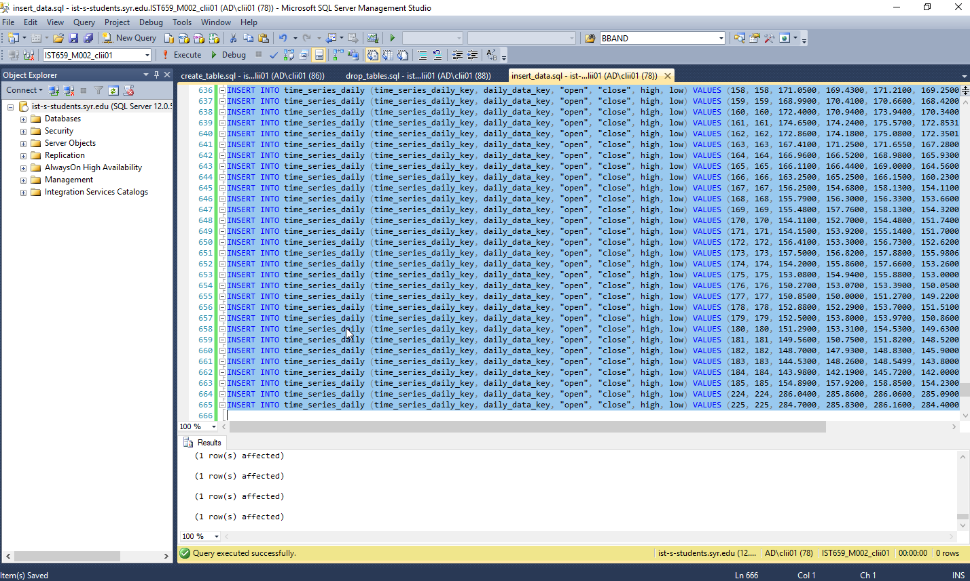

# Suggestions and Improvements

A common suggestion was adding buttons and clarifying the report/form names. Some data questions were also suggested. I decided to rename the report/form names and add buttons to the forms, and clarify many of the data questions.

Professor Yang

1. Add buttons to forms for adding and deleting a record, and traversing records
2. Report have more readable names
3. Add a new report, see all technical data, grouped by ticker

John

1. Putting company name into the reports

Ming Xuan

1. Make data question for recommending when to buy stock

Jessica Dischiave

1. Change the names of the forms and reports to be more readable
2. Add buttons to the bottom to go between forms.

Vidisha

1. Change the names of the attributes so they can be easily read
2. Add buttons to navigate between forms

Jing Wang

1. Remove things like "dbo_macd" from forms
2. Add button to save and delete data.

Mingkang Zhang

1. Write a query looking at a specific stock, and whether or not it went up or not

# Data Questions

## Get all the stock price data for a particular day

SELECT *

FROM daily_data

join time_series_daily

on daily_data.daily_data_key = time_series_daily.daily_data_key

join ema

on daily_data.daily_data_key = ema.daily_data_key

join macd

on daily_data.daily_data_key = macd.daily_data_key;

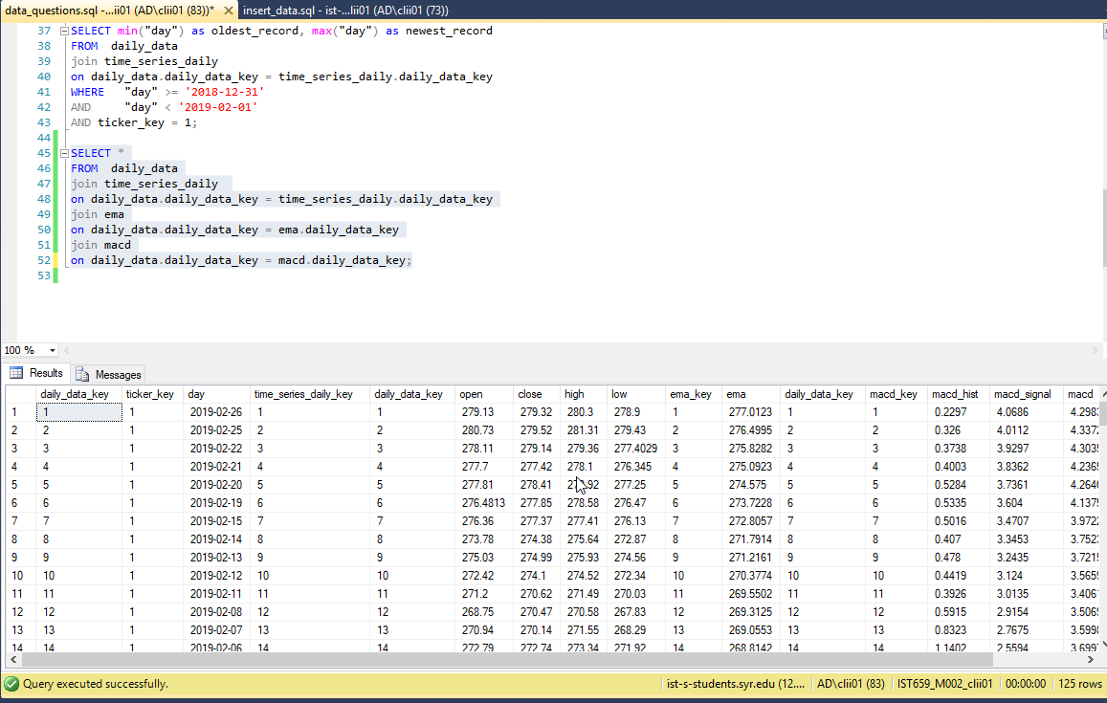

## Find the best Recommendation Strategy

SELECT TOP 1 *

FROM backtest_result

ORDER BY backtest_result.percent_success desc;

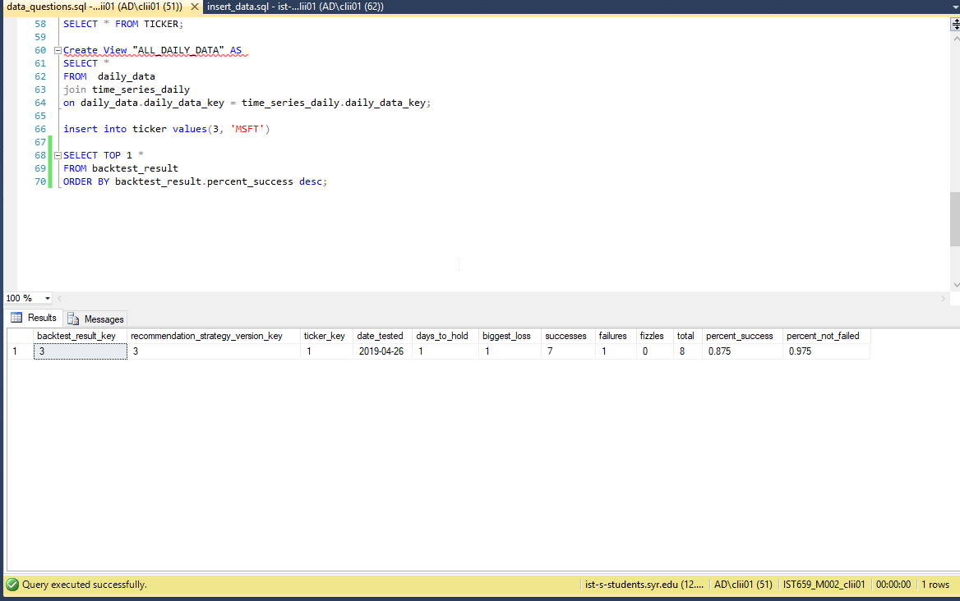

## Find the Weighted Daily Price for the first quarter of 2019, for a particular stock

SELECT "day", (2*"open" + 3*"close" + "high" + "low")/7 as weighted daily price

FROM daily_data

join time_series_daily

on daily_data.daily_data_key = time_series_daily.daily_data_key

where "day" > '2019-01-31'

and "day" < '2019-04-01'

and daily_data.ticker_key = 1

order by "day" desc;

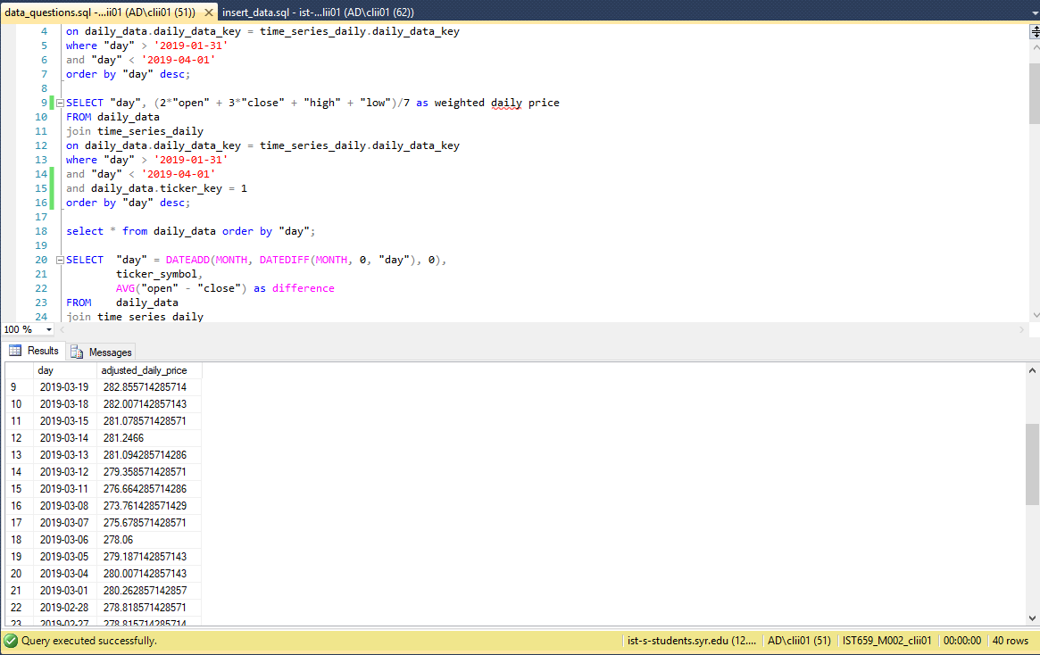

## Find the highest and lowest weighted price for the month of March

select max((2*"open" + 3*"close" + "high" + "low")/7) as HIGHEST, MIN((2*"open" + 3*"close" + "high" + "low")/7) as LOWEST

from time_series_daily

inner join daily_data on daily_data.daily_data_key = time_series_daily.daily_data_key

where "day" > '2019-02-28'

and "day" < '2019-04-01'

and ticker_key = 1;

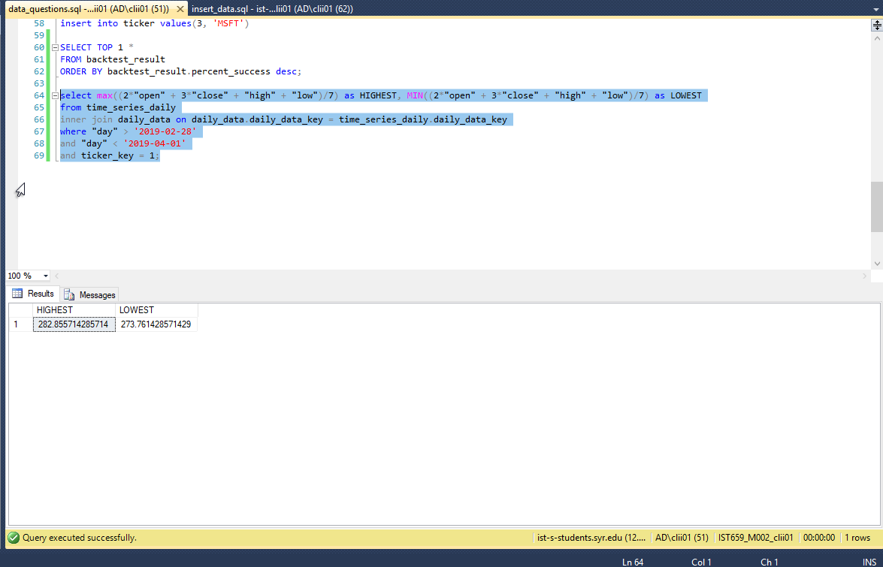

## Find all the days the weighted stock price is above or below the Bollinger Bands for the SPY stock

select "day", (2*"open" + 3*"close" + "high" + "low")/7 as Weighted_Stock_Price, real_lower_band, real_upper_band

from daily_data

inner join time_series_daily on daily_data.daily_data_key = time_series_daily.daily_data_key

inner join bbands on bbands.daily_data_key = daily_data.daily_data_key

where ((2*"open" + 3*"close" + "high" + "low")/7 > real_upper_band

or (2*"open" + 3*"close" + "high" + "low")/7 < real_lower_band)

and ticker_key = 1;

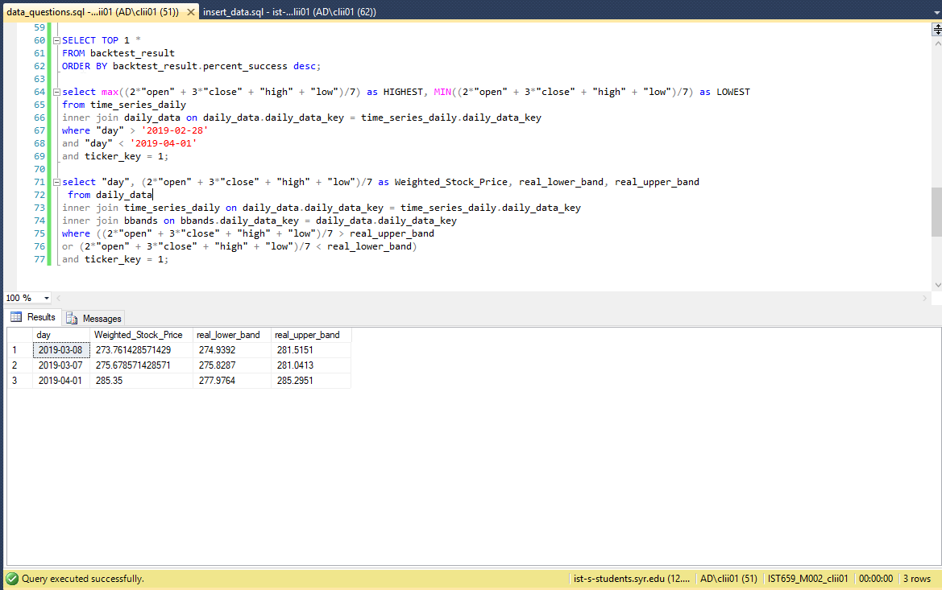

## Find all days where the weighted stock price is below the 10-Day EMA

select "day", (2*"open" + 3*"close" + "high" + "low")/7 as Weighted_Stock_Price, ema

from daily_data

inner join time_series_daily on daily_data.daily_data_key = time_series_daily.daily_data_key

inner join ema on ema.daily_data_key = daily_data.daily_data_key

where ticker_key = 1

and (2*"open" + 3*"close" + "high" + "low")/7 < ema;

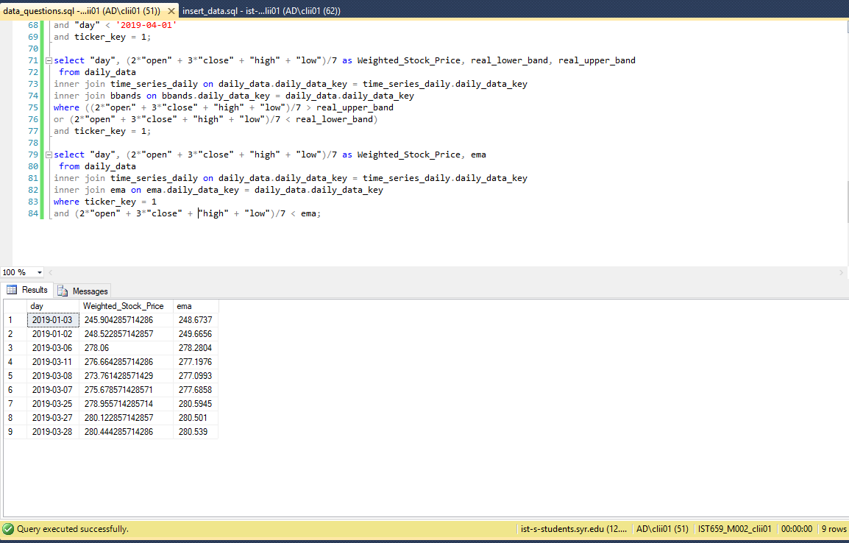

# Forms

## Daily Data Add/Delete Form

This form allows users to add new daily data or remove daily data. It has multiple subforms to make allow people to see, add, and delete the details of other tables.

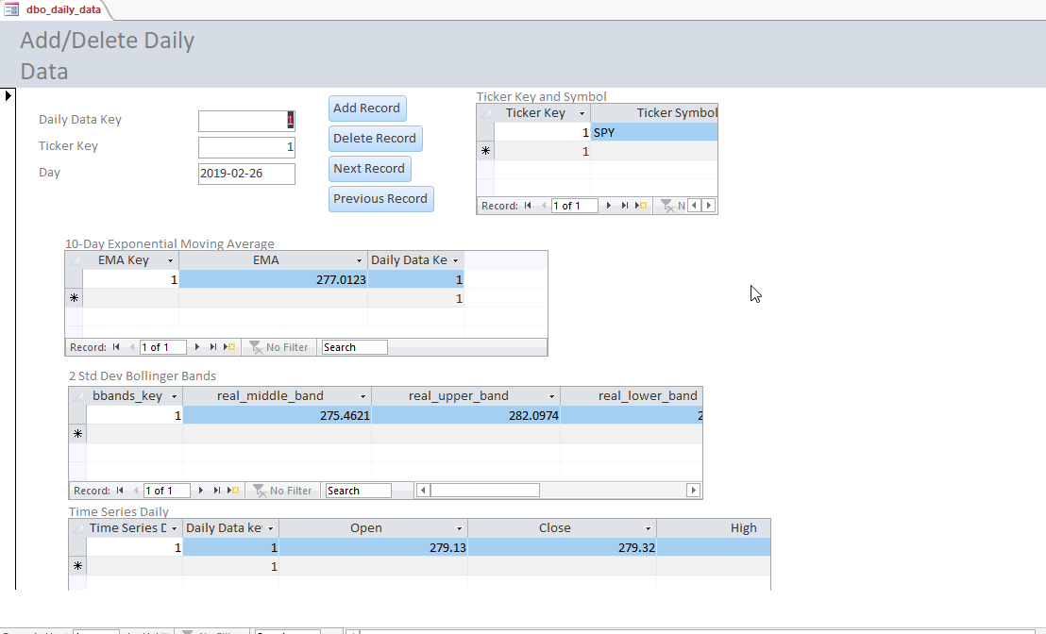

## Daily Data Details Lookup/Modification

This interface allows users to look up a particular day’s data and modify it according to their needs.

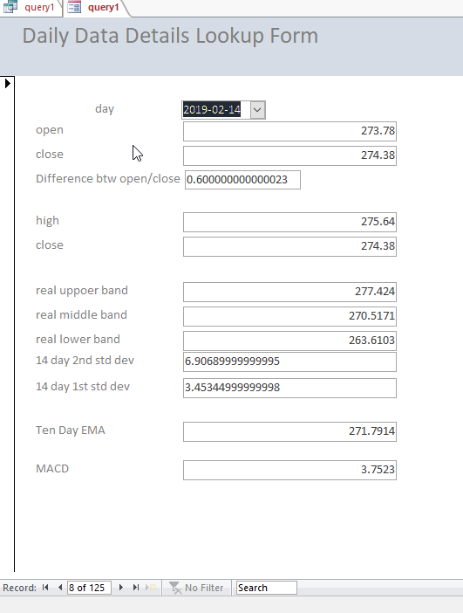

## Add/Delete Recommendation Strategy and Version Form

The purpose of this form is to allow user to add or delete new recommendation strategies and versions. Per peer review suggestions buttons were added and form names were clarified.

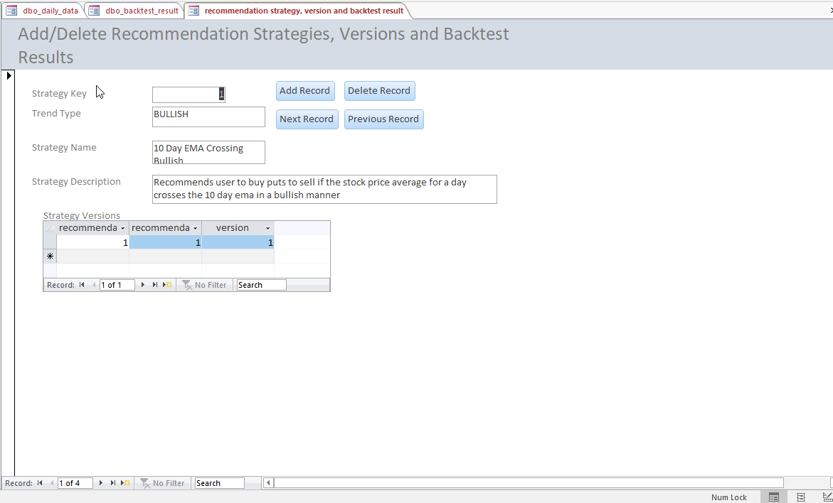

## Add/Delete or Modify Strategy Version and Backtest Result Form

This form is to add/delete or modify backtest results for a given recommendation version strategy

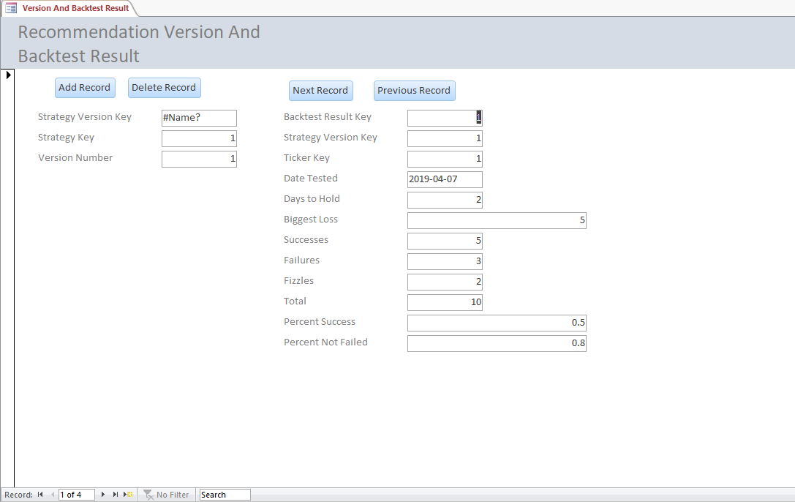

## Add/Delete or Modify Tickers

The purpose of this form is to add, delete or modify tickers. Per peer suggestions, buttons were added and names were clarified. A subform to the backtest result table was also added, to see what would be deleted when deleting the ticker rows.

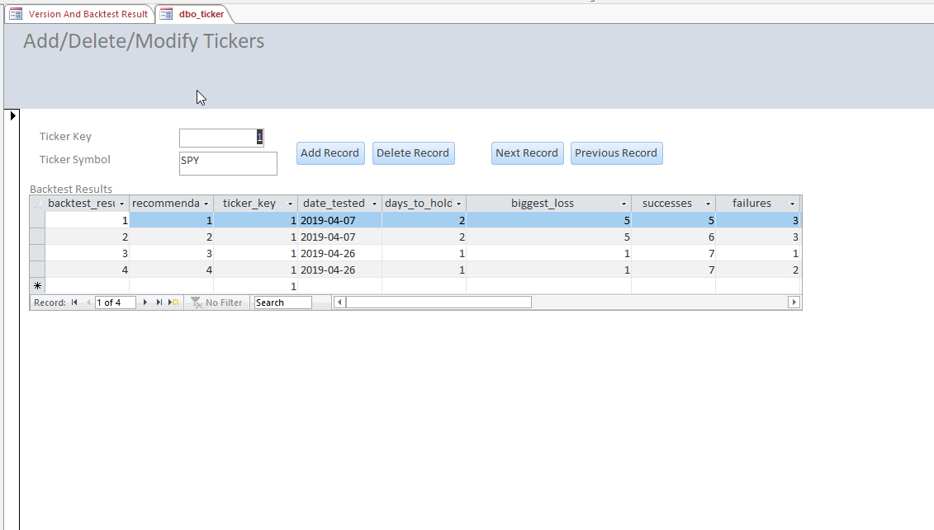

# Reports

## Daily Stock Data Report

This Daily Stock Data Report shows important technical data for a particular day. As per improvements suggested by peers, the names have been clarified, and some distracting fields have been removed. The report also now sorts by Ticker Symbol.

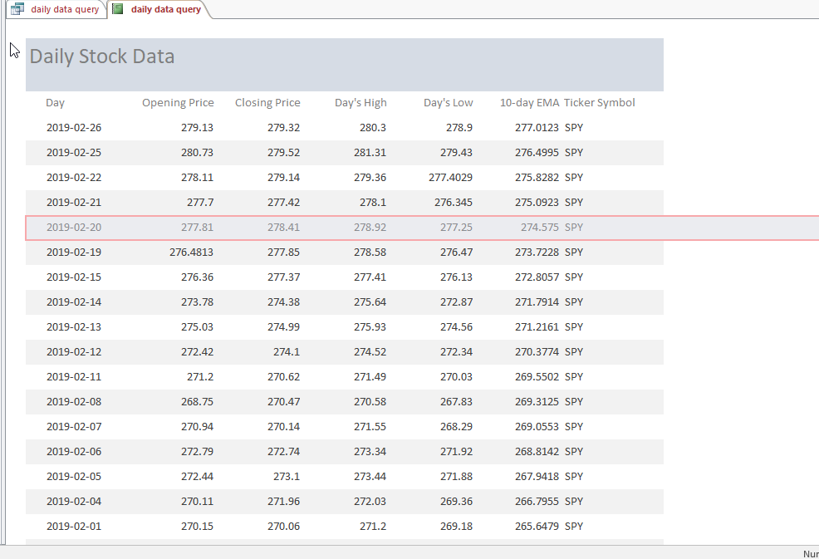

## Backtest Result Report

This Backtest Result Report shows recommendation strategies and their backtest results, sorted by success rate, perfect for picking which strategy to use. Per the peer suggestsion, unnessary fields were removed, and the naming was clarified.

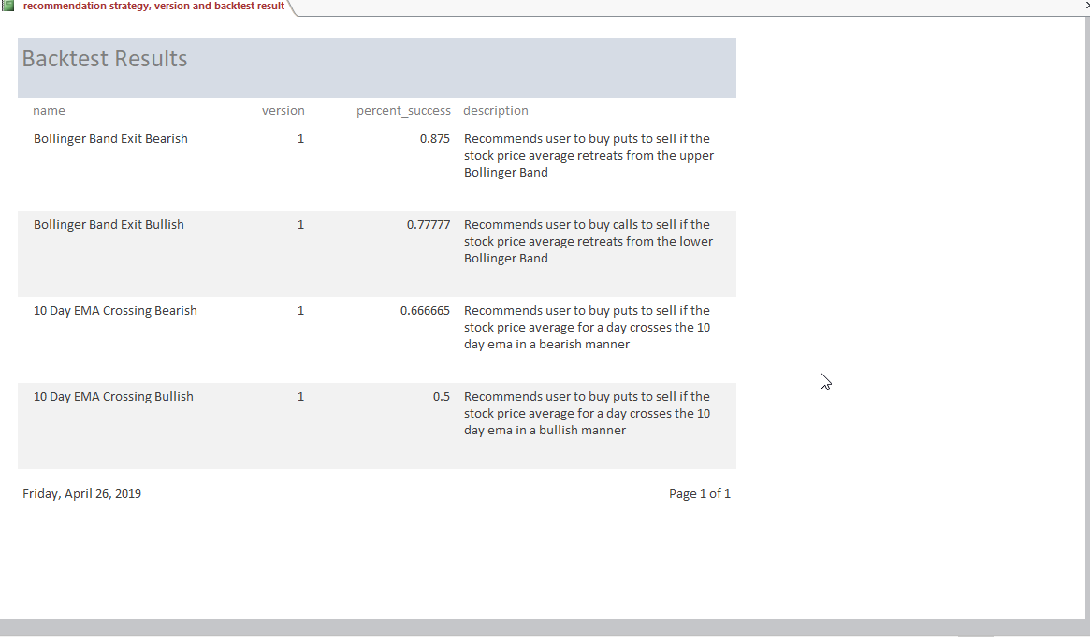

## Weighted Daily Price Report

When analyzing stock data, it is useful to weigh the various data using different values. This report calculates a weighted daily price for a specific price and put it into a report.

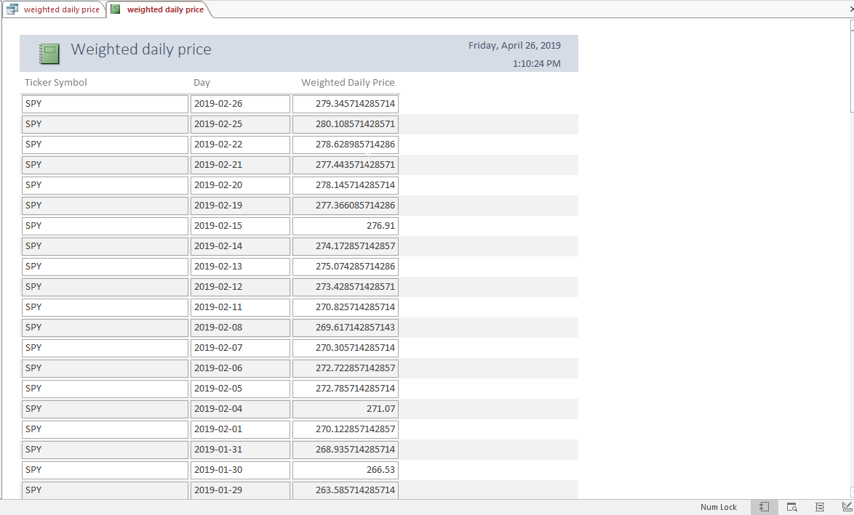

## Days where the weighted stock price was below the ema

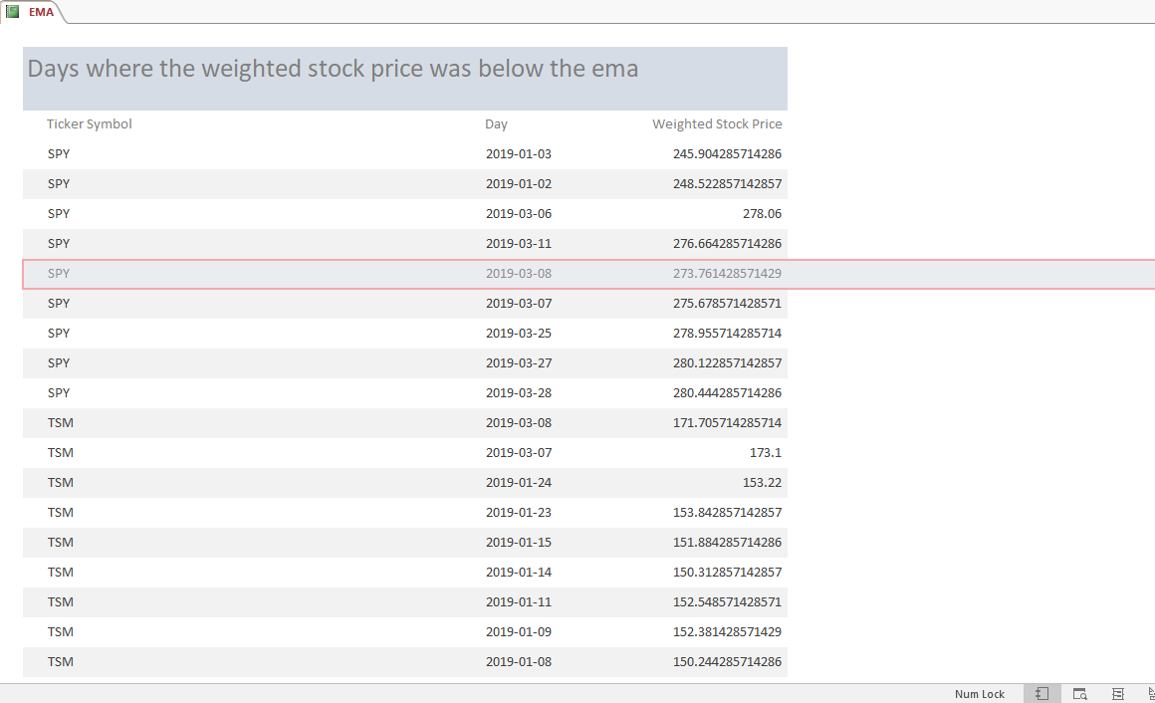

## Days where the weighted stock price is lower than the lower Bollinger Band

